Name:__________________________ Due Date:_________________
Unit 3 Test Study Guide: Federalism and the Constitution
Be sure to review all terms from Unit 3 Vocabulary list. Don’t forget to go to my website ( anderson2019.weebly.com ) for extra information to help you complete the study guide.

- What are the “Articles of Confederation”?

- What were the problems presented by the Articles of Confederation? How did the Constitution resolve these issues with compromises?

- Explain the Virginia Plan and the New Jersey Plan.

- What was the Three-Fifths Compromise?

- What was 1 other compromise made during the Constitutional Convention?

- Compare and contrast the Articles of Confederation with the Constitution.

- Which founding father stands out as the “master builder” of the Constitution?

- The Federalists supported the Constitution, which types of people tended to be Federalists?

- The Anti-Federalists opposed the Constitution, which types of people tended to be Anti-Federalists?

- What were the Federalist Papers and what was the goal/purpose of them?

- Who wrote the Federalist Papers?

- How is the Bill of Rights associated with the ratification of the Constitution?

- What are 4 rights given in the first 10 amendments of the Constitution (the Bill of Rights).

- What are the 7 Principles of the Constitution?

- What is the Elastic Clause?

- What are the three branches of government?

- What is the overall purpose of each branch of government?

- How do the three branches of government “check” the other three branches?
Make sure you know the first 10 amendments (Bill of Right

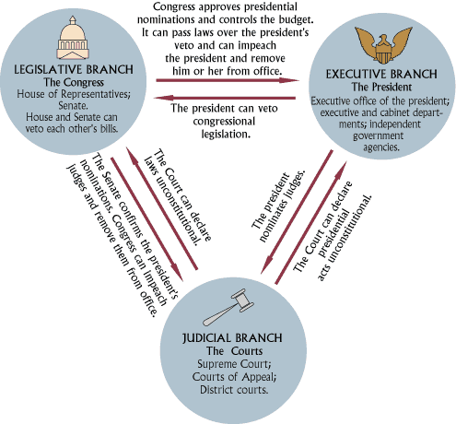
Use this as a review ^^^^

