Name:_________________________________ Period: 1 3 4 Due Date:____________________________
World History: Unit 1 Test Review – Ancient Civilizations and World Religions

- What is a primary source? Provide an example.

- What is a secondary source? Provide an example.

- Draw a timeline – label the correct side with BC/BCE and AD/CE. What does BC/BCE and AD/CE stand for?

- Name the 7 characteristics of a civilization.

- Use the map below; label the 5 main rivers for the civilizations (Egypt, Mesopotamia, Indus, China) 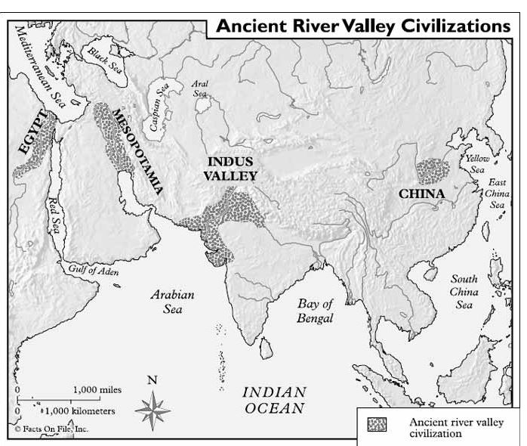

- How did water play a role in ancient civilizations and what were special characteristics for the river in each civilization below?
  - Egypt

  - Mesopotamia

  - Indus Valley

  - China

- What features of ancient civilizations lead to the migration of people and result in the spread and adaptation of ideas, customs, and technologies? What influenced settlement?

- Define Republic and Democracy and explain the difference of the two words.

- What is cultural diffusion? How did it impact or influence civilizations? Provide at least one example.

- What are the holy texts for each of the following:
  - Christianity

  - Judaism

  - Islam

  - Hinduism

  - Buddhism

- What do the holy texts have in common? How do they impact society?

- Is there an afterlife or rebirth? How does one achieve afterlife or reincarnation in the following religions:
  - Christianity

  - Judaism

  - Islam

  - Hinduism

  - Buddhism

- How did social class play a role in the ancient civilizations? Below is a social class pyramid; you will want to add more detail for specific civilizations if they differ.
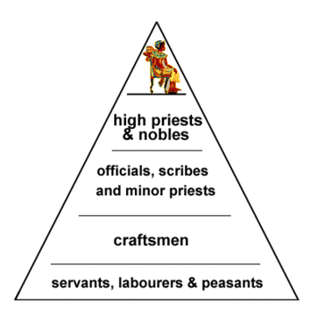

- How and why did ancient laws enforce class divisions?

- Label where the religions began on the map and draw arrows to show where they moved to (you may want to watch the video on my website): Christianity, Judaism, Islam, Hinduism, and Buddhism
- Was the religion polytheistic, monotheistic, or have no gods?
  - Christianity

  - Judaism

  - Islam

  - Hinduism

  - Buddhism
- Define and give an example of jihad (do not use the definition that google provides you with, remember it is specific to Islam).

- List 3 characteristics for each of the following, these could be government, class, gender, architecture, etc.:
  - Athens

  - Sparta

  - Rome

- How did the Roman government differ from Greece? What were the tribunes in Rome and what was their purpose?

- How did trade impact civilizations?

- What was a common theme for Greece and Roman treatment and view of women?

- What is a legacy?

- What was a legacy of Alexander the Great?

- What was a specific legacy from the following, explain your answers:
  - Roman Empire

  - Greeks

  - Mesopotamia

  - Egypt

  - Sumer

