Name:____________________ Unit6: The Industrial Revolution Guided Notes
- What are fair working conditions (please give details)? If working conditions are not fair, how do you change them?

- What was the Industrial Revolution?

- Why did the Industrial Revolution being in Great Britain?
  - What do you notice about the map that can help you answer the question?

- Causes of the Industrial Revolution in England

- What 5 main developments and improvements occurred?

- Name two disadvantages from the first video clip.

- According to the second video clip why is coal an improvement? Predict positive and negative effects of the use of coal for energy?

- How fast was the Spinning Jenny?

- How did James Watt’s invention of the steam-engine change society?

- Assembly line – What roles do people have? What roles do machines have? How are the two videos diferent/similar?
  - I Love Lucy

  - Ford

- Working Conditions activity– see handout – take your own notes as the class provides a summary of the text.

STOP: We will continue the notes tomorrow

- Small group activity notes:
  - “Life in a New England Factory”

  - James Watt

  - “The opening of the Liverpool to Manchester Railway”

  - A Woman Coal Mine Worker Tells Her Story

- What happened due to urbanization?

- Based on the clip, what is capitalism?

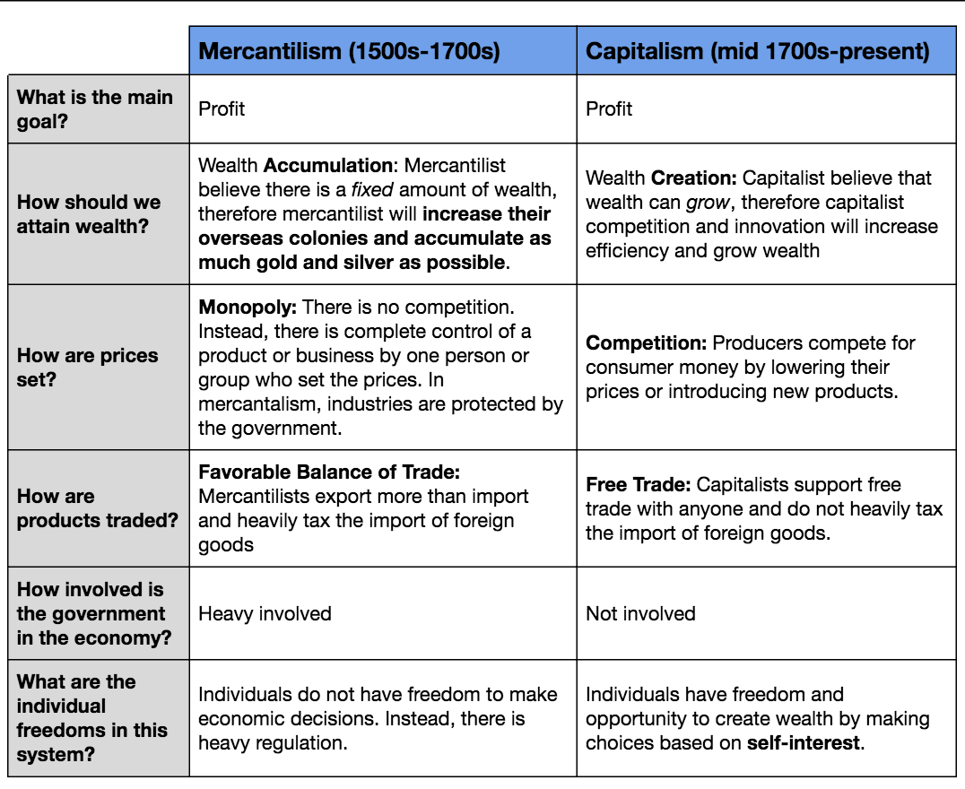
- What similarities and differences do you notice between the economic systems above?

- Industrialization Changes
  - Transportation

  - European society

  - Reform/Improvements

“Necessity is the Mother of Invention”- the process of inventing never ends; one invention inevitably leads to improvements upon it and to more inventions.
Honors HW//Academic E.C.: Crash Course: Industrial Revolution Video Fill-In Notes
- Made it possible for you to watch ______________ ____________!
- Most ____________________________ of the bunch?
  - Electricity, blueberries in February, 12 years of _____________ education, driving a car, tap water- Industrial Revolution!
- Before: ___________ % of world’s population engaged in farming
  - What happened? __________________________
    - Increase in _________________ brought about by the use of machines, and characterized by the use of new energy _________________
      - NOT capitalism but connected to capitalism
- Started in Europe especially _______________________
  - Flying ______________ invention increased the speed of weaving which increased ______________ for yarn which led to invention of the spinning _____________ and the water _______________
  - James _________________ perfected the steam engine which made the railroad possible and cotton mills more efficient
  - Sulfuric acid (rather than __________________) used to bleach clothing
    - Eurocentric reasons for WHY
      - Cultural superiority: Europeans are ________________ and ________________ than other people
      - Culture of science and _______________________ that made these inventions possible
      - Freer political institutions encouraged __________________________
      - Small populations encouraged ________________-saving inventions
        - Problem: there’s a cause of every ___________ cause!
    - All the Eurocentric answers can apply to China or India or both!
- Answer to WHY: coal
  - Steam engines were invented to pump _________________ out of the coal mines
    - British used steam engines to keep British ______________ cheap
  - Wages: highest in world at beginning of 18th century
    - High wages + cheap ________________= economic efficiency
      - Incentives to lower production costs
      - Indian cotton production was productive without using __________________ so they didn’t need to industrialize

