Name:___________________ Review Think-Pair-Share
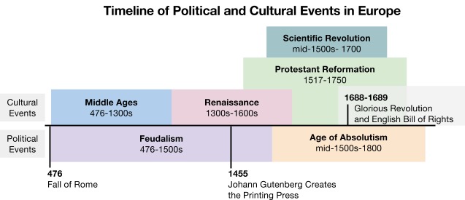
Topic | 1. Think  Independently, write anything you can remember about the topic. | 2. Pair  Explain everything you wrote in the “Think” column to a partner then, ask them to do the same. Add new information from your partner below.
Middle Ages
Feudalism
Renaissance
Protestant Reformation
Exploration
Age of Absolutism
3. Share
With your partner, select the most important fact from each section to share with the class.

