Unit 3 Notes Name:_______________________

**Notes**:

**Part I: Tracing the Ideas that Led to the Renaissance**

Macintosh HD:Users:juliamaurer:Downloads:9.7 SQ 3. What was the Renaissance? - Google Docs.pdf

1. List the golden ages in the graphic above in chronological order.
2. Which civilization’s ideas were the foundations for collective learning in the Mediterranean world?
3. Identify two examples of innovation described in the chart.
4. Based on the dates and information provided, which civilization’s knowledge most directly influenced the start of the Renaissance?

**Part II: Success and Failure during the Renaissance**

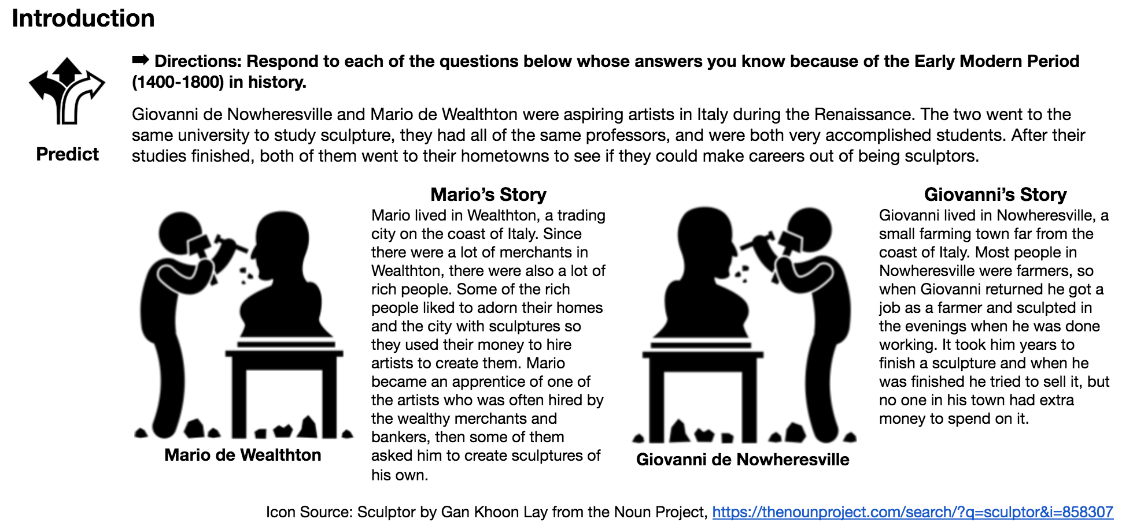

1. Why did Mario become a successful artist and Giovanni did not?

**Part III:**

