Video: The Paleolithic Era
➡ Directions: Watch excerpts of the videos “Stories from the Stone Age (1 of 15)” (1:00-5:30) and “Stories from the Stone Age (2 of 15)” (start-3:28, 8:15-8:42), then respond to the prompts below.
1. What food did people eat in the Paleolithic Era? | 2. How did people get food in the Paleolithic Era? | 3. Approximately how many people lived together in Paleolithic communities?

4. What effects did the hunter-gatherers in the videos have on their environment? | 5. What effects did their environment have on them?

6. In the chart below, identify two advantages (+) and two disadvantages (-) of being a nomad and hunting and gathering for one’s food.
+ | -

What was the Neolithic Revolution?
➡ Directions: Read and annotate the definition below and define the review terms on the left hand side. Then, read the words, definitions, and examine the images related to each of the vocabulary words below, then predict the effects of each innovation on Paleolithic people.

The Neolithic Revolution was a turning point in history that changed the way Paleolithic people live their lives. People shifted from hunting and gathering for food to agriculture. Instead of living as nomads, people settled down in permanent settlements. The Neolithic Revolution led to the first civilizations. | Define turning point-  Define hunting and gathering-  Define agriculture-

Innovation & Definition | Image | What effects might this innovation have had on Paleolithic people?
agriculture- farming | 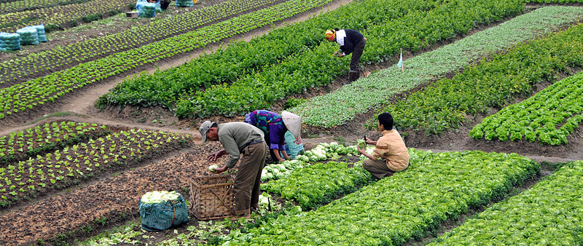  Agriculture in Vietnam with farmers.jpg by Dennis Jarvis is published under the Creative Commons Attribution-Share Alike 2.0 Generic license
domestication- the act of changing a wild plant or animal so it can be grown or raised by humans | Image is courtesy of Public DomainPictures.net and is in the public domain
permanent settlements- places where people live for long periods of time, possibly for their whole lives | Laténium-maquette-village-laustre.jpg by Laténium is published under the Creative Commons Attribution-Share Alike 3.0 Unported license

