Name:______________________________________________ Unit 4 – Global Exploration

- Based on the clip, why do you think the legacies left by the explorers are complicated?
- What is your definition of the word conquer/conquering?
- Which statement did you pick that you most agree with? Explain your choice.
- The Age of Exploration started in the __________ century and continued through the ________ century.
- The Age of Exploration led to the first truly global _________________________________.
- What are some details about the Old and New world?
Old World | New World

Directions: Read the texts and examine the images below that explain the reasons why Europeans wanted to explore the world in the late 1400s. Answer the questions that accompany each section using complete sentences, and then complete the synthesis task at the end.
Cause #1: Interest in the East  Though Western Europe was isolated from trade with Asia during most of the Middle Ages, the Crusades and books by travelers like Marco Polo kept Europeans interested in the lands east of the Mediterranean Sea. Stories about the riches of China and India, and the limited availability of goods like silk and spices from those areas fueled European desire for adventure and profit.  1. Why were Europeans interested in exploring Asia? | 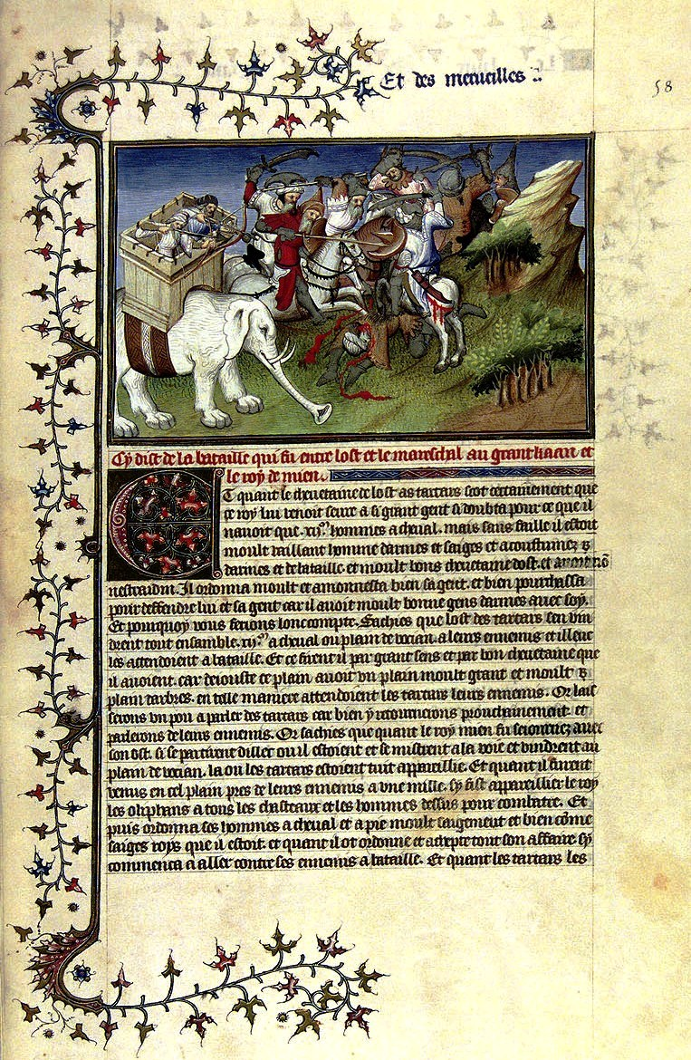

Cause #2: Eastern Influence and Pricey Spices

Access to Trade in the Middle Ages through Christian Allies
In the Middle Ages, Europeans had access to spices and other goods from Asia because they could easily trade with the Byzantine Empire, a Christian empire that controlled the city of Constantinople, which was a crossroads for trade.
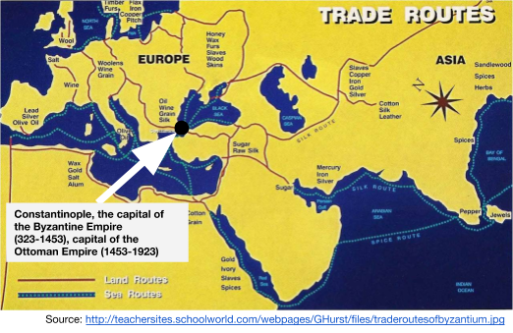 | 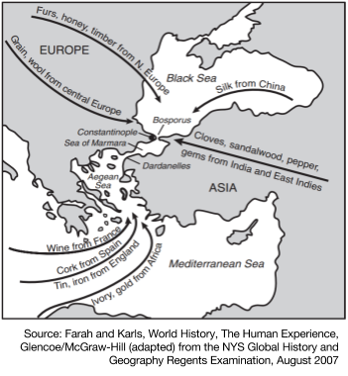

2. In the Middle Ages, why was the relationship with the Byzantine Empire (Constantinople) important for Western Europeans? (Take a careful look at the maps)

Cause #2 part 2 - Increasingly Expensive Trade
Europeans wanted more goods from Asia, especially gold and spices like pepper, cinnamon, cardamom, ginger, and turmeric, but by the time the spices travelled from southeast Asia to Europe they were incredibly expensive. To get spices to Europe, they travelled from southeast Asia in caravans along the Silk Roads or on ships in the Indian Ocean to the Middle East where they were then shipped across the Mediterranean Sea to European markets. It was rare for one trader to buy the spices in southeast Asia and take them all the way to Europe. Instead, the spices were bought and sold many times from their origin to their final destination. To make a profit, every merchant that bought the spices from another raised the price so, buying pepper in Malaysia was cheapest, India was a little more expensive, buying it in the Middle East was more expensive still, then the price went up in Constantinople, it was bumped up higher in Venice, and so on and so forth all the way through Europe. Spices in places as far away as Portugal, Spain, or England were so expensive that only the wealthiest Europeans could afford them.
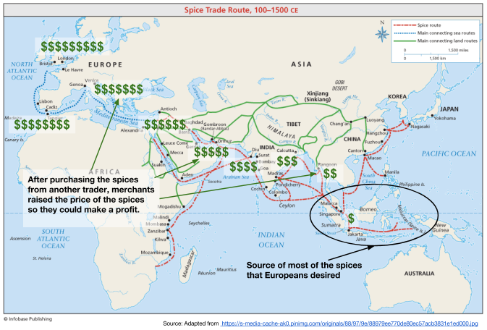

4. Why were spices so expensive in Western Europe?

5. If you lived in Western Europe and wanted spices for less money, what would you do?

Cause #3: Religious Zeal [enthusiasm; passion]

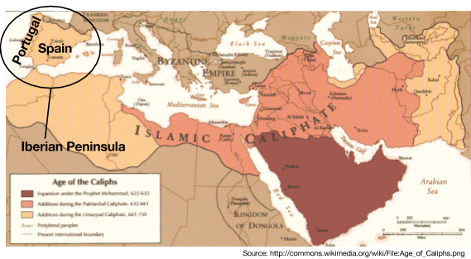
Portugal and Spain were the first European countries to send ships out on trading expeditions. Both countries were located on the Iberian Peninsula, the region of Europe that is closest to North Africa, only separated by the Strait of Gibraltar. In the 700s, Muslim forces invaded from North Africa and settled in parts of both Portugal and Spain. For almost 800 years there were battles between Christian (Roman Catholic) forces and Muslims over the land. The Christian monarchs and Popes declared Crusades to rally forces against Muslims. In the 1200s, the momentum swung in favor of the Christian armies and in 1492 the Muslim government that controlled Granada signed a treaty with Ferdinand and Isabella, the King and Queen of Spain, finally ending what the Christians called the Reconquista, the reconquering of the Iberian Peninsula.
One Spanish soldier who helped conquer the Americas wrote that he joined the exploration to “serve God and His Majesty [the King of Spain], to give light to those who were in darkness, and to grow rich, as all men desire to do.” For that soldier and for many Europeans, spreading Christianity was an important reason for going too far away lands.

After 800 years of fighting religious wars, the Portuguese and Spanish turned their devotion to the Catholic Church to those they encountered through exploration. Explorers were sponsored (funded) by the Catholic Kings and Queens of their countries. They viewed voyages to the coast of Africa and eventually to the Indian Ocean and the Americas as opportunities to convert people to their faith. They believed that their religion was the only true religion and that it would benefit them and the soon-to-be converts if they spread the lessons of the Bible. Many ships had priests on board for the sailors and to teach the people they encountered about Christianity.
6. Why was “religious zeal” one of the causes for European exploration?

Cause #4: Mercantilism: An Absolute Monarch’s Policy for Economic Power  At the end of the 15th century, absolute monarchs ruled in almost every country in Europe. The monarchs of Spain, France, Portugal, England, the Holy Roman Empire, and other areas centralized the power in their countries by raising large armies, controlling the people of their countries through harsh laws and military force, and tied their rule to God through the theory of divine right.  Absolute monarchs and the officials working in their governments followed an economic policy that we now call mercantilism. Mercantilists believed that a country was strongest if it had a lot of gold and silver, so monarchs did everything they could to get it. There were two methods for filling their treasuries with gold and silver:  - Maintain a Favorable Balance of Trade  When thinking about mercantilism, imagine a whole country as one business and the absolute monarch is the CEO. If the country sells (exports) more than it buys (imports), it will have more money (gold and silver). For absolute monarchs, a “favorable” balance of trade one with a lot more exports than imports.  - Establish Colonies, Import their Raw Materials, and Sell Good Manufactured  Absolute monarch saw establishing colonies as a great way to bring in silver and gold through mining and through trade. When explorers were sent out to Africa, Asia, or the Americas, the kings and/or queens that sent them hoped they would find new sources of gold and silver. Monarchs also hoped to find people they could trade with. They wanted to buy raw materials (fur, crops, lumber) at a low price from the inhabitants they encountered, then bring those goods back to the mother country where the raw materials would be turned into manufactured goods like clothing and sold back to the colonies at a higher price.  By following the policy of mercantilism monarchs hoped to get more gold and silver that they could then use to pay for larger and more modern armies that they could use to conquer more area and continue to secure more silver and gold.  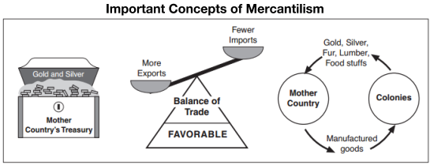 | 7. If you were an absolute monarch (complete power) who followed the theory of mercantilism, what steps would you take to make your kingdom wealthier and more powerful (list at least two)?  8. Why did the theory of mercantilism motivate European monarchs to sponsor explorers?

Synthesis Task
Using the information provided on the previous pages, write a paragraph in which you explain why the Age of Exploration started. Be sure to discuss all four of the causes mentioned.

________________________________________________________________________________________________________________________________________________________________________________________________________________________________________________________________________________________________________________________________________________________________________________________________________________________________________________________________________________________________________________________________________________________________________________________________________

Wrap up:
What led up to this point?
1.

2.

3.
What were the reasons to go abroad? (Provide examples and your own notes for each.)
- Gold

- God

- Glory

