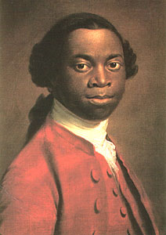
Purpose for reading: What story would Olaudah Equiano tell about the Age of Exploration?
olaudah equiano
African slave and author
Secondary Source: The Middle Passage
The Middle Passage may have served to enrich many Europeans and Americans, but the enslaved Africans suffered extraordinary atrocities and inhuman conditions during these voyages. The journey from Africa to North America could take between thirty and ninety days. The vessels were called "loose packers" or "tight packers," where captives were laid side by side, coffin like, beneath the deck. The ships carried the stench of diseased and decaying bodies, and slavers often threw Africans that were misbehaving overboard, which lured sharks along these shipping lanes. When captives seemed too sick to survive the journey, slavers were known to throw the weak and sick into the sea.
Unsanitary conditions aboard ship on the longer journeys created high mortality rates, encouraged by the incidence of smallpox, eye infections, gastrointestinal disorders, and body sores. "Fever" and "flux" were the terms used to describe common causes of death during the ocean crossing, and some slaves committed suicide by refusing to eat or throwing themselves overboard. Ships sometimes reported slave rebellions, and the result became a maritime standard of even harsher and more brutal handling.

Purpose for reading: What are the key parts of Montezuma’s story about the Age of Exploration?
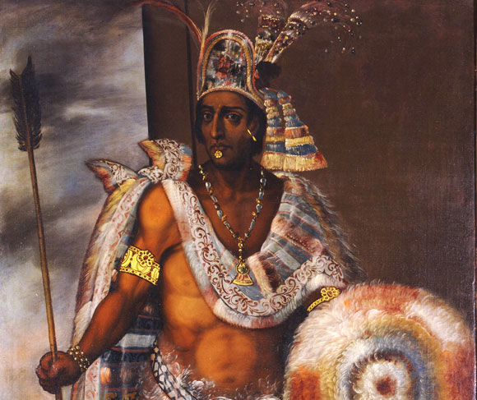
Montezuma, Aztec Emperor
Secondary Source
His reign was marked by incessant warfare, and his strict ruling style caused grave unrest. When Hernán Cortés arrived in Mexico, Montezuma was thus able to gain native allies. Montezuma, believing the Spanish to be descendants of the god Quetzalcoatl, tried to persuade them to leave by offering rich gifts. That failing, he received them in his splendid court at Tenochtitlán in Nov., 1519. Cortés later seized him as a hostage and attempted to govern through him. In June, 1520, the Aztec rose against the Spanish. Montezuma was killed, although whether by the Spanish or the Aztec is not certain. His successor died a few months later and was replaced by Cuauhtémoc. Montezuma's name is linked by a legend to fabulous treasures that the Spanish appropriated and presumably lost at sea.
H. Thomas, Conquest: Montezuma, Cortés, and the Fall of Old Mexico (1994).
Primary Source
A Promise is a Lie
When Montezuma had finished, La Malinche translated his address into Spanish so that the Captain could understand it. Cortés replied in his strange and savage tongue, speaking first to La Malinche: "Tell Montezuma that we are his friends. There is nothing to fear. We have wanted to see him for a long time, and now we have seen his face and heard his words. Tell him that we love him well and that our hearts are contented."
Then he said to Montezuma: "We have come to your house in Mexico as friends. There is nothing to fear."
A Bloody Betrayal
The Spaniards hanged a chief. They also murdered a king, by wounding him with arrows and then burning him alive.
For this reason, our warriors were on guard at the Eagle Gate. We were celebrating one of our holidays in the main temple.
The people began to sing their songs. That is how they celebrated the first day of the fiesta. On the second day they began to sing again, but without warning they were all put to death. The dancers and singers were completely unarmed. They brought only their embroidered cloaks, their turquoises, and their drums.
The Spaniards attacked the musicians first, slashing at their hands and faces until they had killed all of them. The singers-and even the spectators- were also killed. This slaughter in the Sacred Patio went on for three hours. Then the Spaniards burst into the rooms of the temple to kill the others: those who were carrying water, or bringing fodder for the horses, or grinding meal, or sweeping, or standing watch over this work.
The king Motecuhzoma, who was accompanied by Itzcohuatzin and by those who had brought food for the Spaniards, protested: "Our lords, that is enough! What are you doing? These people are not carrying shields or weapons. Our lords, they are completely unarmed!"
The Sun had treacherously murdered our people on the twentieth day after the captain left for the coast. We allowed the Captain to return to the city in peace. But on the following day we attacked him with all our might, and that was the beginning of the war
From Miguel Leon Portilla, ed., The Brohen Spears: The Aztec Account of the Conquest of Mexico (Boston: Beacon Press, 1962), pp. 6466, 129131.

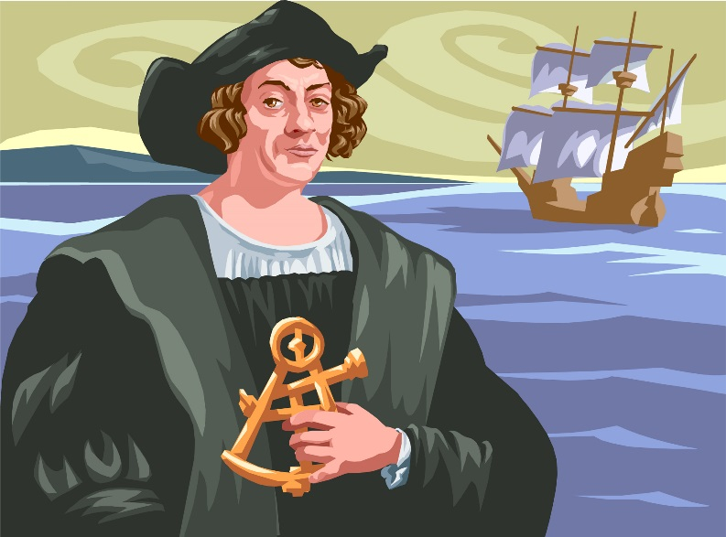
Purpose for Reading: What story would Christopher Columbus tell about the Age of Exploration?
Christopher Columbus
European Explorer
Secondary Source
Rejected by the Portuguese king for a three-ship voyage of discovery, Columbus took his plan first to Genoa and then to Venice but was rejected there too. He then went to the Spanish monarchy of Isabella of Castille and Ferdinand of Aragon, in 1486. Their nautical experts too were skeptical and initially, Columbus was rejected. The idea however, must have intrigued the monarchs, for they kept Columbus on a retainer. But their focus was on a war with the Muslims and Columbus would have to wait.
Columbus continued to lobby the royal court and soon after the Spanish army captured the last Muslim stronghold in Granada in January of 1492, the monarchs agreed to finance his expedition. In August of 1492, Columbus left Spain in the Santa Maria, with the Pinta and the Niña along side. After 36 days of sailing, Columbus and several crewmen set foot on an island in the present day Bahamas, claiming it for Spain. There he encountered a timid but friendly group of natives who were open to trade with the sailors exchanging glass beads, cotton balls, parrots and spears. The Europeans also noticed bits of gold the natives wore for adornment.
Columbus and his men continued their journey, visiting the islands of Cuba and Hispaniola (now Haiti and the Dominican Republic) and meeting with the leaders of the native population. During this time, the Santa Maria was wrecked on a reef off the coast of Hispaniola. With the help of some islanders, Columbus' men salvaged what they could and built the settlement Villa de la Navidad ("Christmas Town") with lumber from the ship. Thirty-nine men stayed behind to occupy the settlement. Convinced his exploration had reached Asia, he set sail for home with the two remaining ships.
Primary Source
The island called Juana, as well as the others in its neighborhood, is exceedingly fertile. It has numerous harbors on all sides, very safe and wide, above comparison with any I have ever seen. Through it flow many very broad and health-giving rivers; and there are in it numerous very lofty mountains. All these island are very beautiful, and of quite different shapes; easy to be traversed, and full of the greatest variety of trees reaching to the stars. . . .
In the island, which I have said before was called Hispana, there are very lofty and beautiful mountains, great farms, groves and fields, most fertile both for cultivation and for pasturage, and well adapted for constructing buildings. The convenience of the harbors in this island, and the excellence of the rivers, in volume and salubrity, surpass human belief, unless on should see them. In it the trees, pasture-lands and fruits different much from those of Juana. Besides, this Hispanaabounds in various kinds of species, gold and metals. The inhabitants . . . are all, as I said before, unprovided with any sort of iron, and they are destitute of arms, which are entirely unknown to them, and for which they are not adapted; not on account of any bodily deformity, for they are well made, but because they are timid and full of terror. . . . But when they see that they are safe, and all fear is banished, they are very guileless and honest, and very liberal of all they have. No one refuses the asker anything that he possesses; on the contrary they themselves invite us to ask for it. They manifest the greatest affection towards all of us, exchanging valuable things for trifles, content with the very least thing or nothing at all. . . . I gave them many beautiful and pleasing things, which I had brought with me, for no return whatever, in order to win their affection, and that they might become Christians and inclined to love our King and Queen and Princes and all the people of Spain; and that they might be eager to search for and gather and give to us what they abound in and we greatly need.

Purpose for Reading: What story would Hernan Cortes tell about the Age of Exploration?
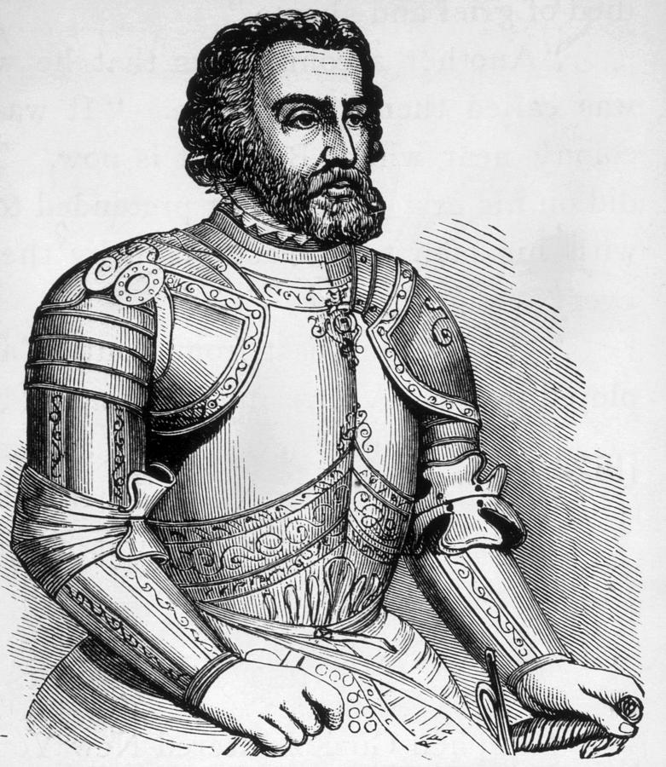
Hernan Cortes
Spanish Conquistador
Secondary Source
In 1518, Cortés was to command his own expedition to Mexico, but Velázquez canceled it. Cortés ignored the order and set sail for Mexico with more than 500 men and 11 ships that fall. In February 1519, the expedition reached the Mexican coast.
Cortés became allies with some of the native peoples he encountered, but with others he used deadly force to conquer Mexico. He fought Tlaxacan and Cholula warriors and then set his sights on taking over the Aztec empire. He marched to Tenochtitlán, the Aztec capital and home to ruler Montezuma II. Cortés took Montezuma hostage and his soldiers raided the city. Cortés left the city after learning that Spanish troops were coming to arrest him for disobeying orders.
After facing off against Spanish forces, Cortés returned to Tenochtitlán to find a rebellion in progress. The Aztecs eventually drove the Spanish from the city, but Cortés returned again to defeat them and take the city in 1521. King Charles I of Spain (also known as Holy Roman Emperor Charles V) appointed him the governor of New Spain the following year.
Primary Source
This city has many public squares, in which are situated the markets and other places for buying and selling. There is one square twice as large as that of the city of Salamanca, surrounded by porticoes, where are daily assembled more than sixty thousand souls, engaged in buying and selling; and where are found all kinds of merchandise that the world affords, embracing the necessaries of life, as for instance articles of food, as well as jewels of gold and silver, lead, brass, copper, tin, precious stones, bones, shells, snails, and feathers. There are also exposed for sale wrought and unwrought stone, bricks burnt and unburnt, timber hewn and unhewn, of different sorts. There is a street for game, where every variety of birds in the country are sold, as fowls, partridges, quails, wild ducks, fly-catchers, widgeons, turtledoves, pigeons, reed-birds, parrots, sparrows, eagles, hawks, owls, and kestrels; they sell likewise the skins of some birds of prey, with their feathers, head, beak, and claws. There are also sold rabbits, hares, deer, and little dogs [i.e., the chihuahua], which are raised for eating. There is also an herb street, where may be obtained all sorts of roots and medicinal herbs that the country affords. There are apothecaries' shops, where prepared medicines, liquids, ointments, and plasters are sold; barbers' shops, where they wash and shave the head; and restaurateurs, that furnish food and drink at a certain price. There is also a class of men like those called in Castile porters, for carrying burdens. Wood and coal are seen in abundance, and braziers of earthenware for burning coals; mats of various kinds for beds, others of a lighter sort for seats, and for halls and bedrooms.
Source.
From: Oliver J. Thatcher, ed., The Library of Original Sources (Milwaukee: University Research Extension Co., 1907), Vol. V: 9th to 16th Centuries, pp. 317-326.
Scanned by Jerome S. Arkenberg, Cal. State Fullerton. The text has been modernized by Prof. Arkenberg.

