Name:____________________________________
Unit 5 – Enlightenment and Revolutions Guided Notes

- What is Enlightenment?

.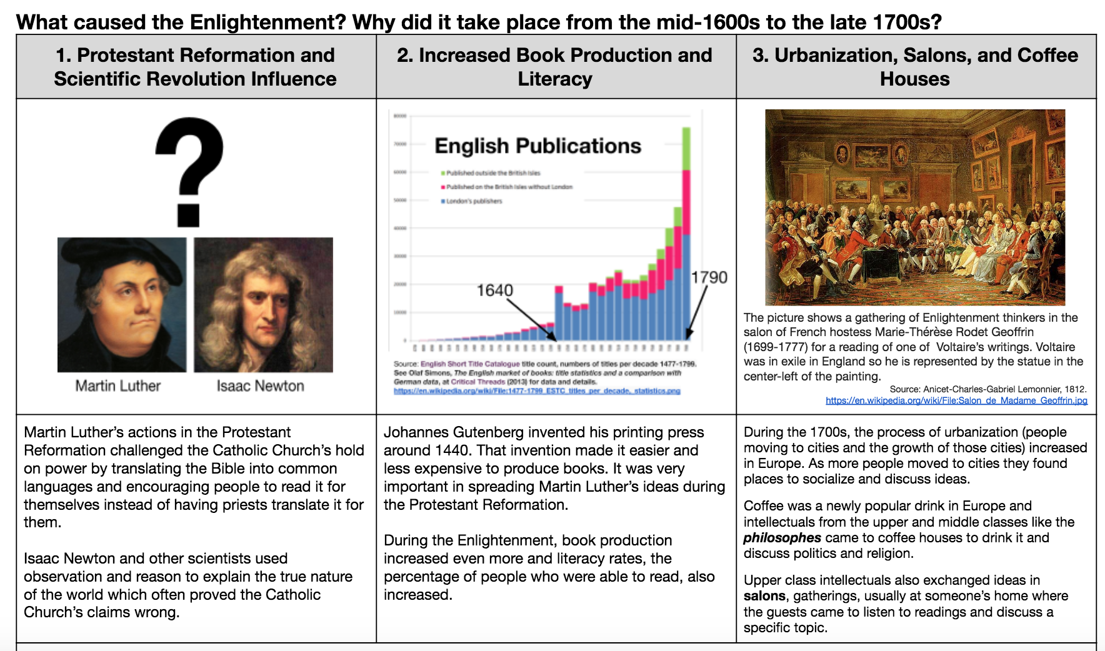
- Based on the information above, summarize what the mid-1600s to late 1700s were like in Western Europe and explain why this time period was ripe for the Enlightenment.

- How is the Enlightenment similar to the past eras?

- What is new with Enlightenment?

- Why would scientific advancement spark change?

- How have we seen this during our own modern times?

- Define Natural Law:

- 5 Core beliefs of a Philosophe
  - Reason:

  - Nature:

  - Happiness:

  - Progress:

  - Liberty

- What were Thomas Hobbes beliefs?

- What were John Locke’s beliefs?

- How did most philosophes view women’s natural rights?

- Define laissez faire:

- Who was Adam Smith and what did he believe about the economy?

