EARLY HUMAN DBQ - H Name:__________________

Historical Context:
The earliest people in prehistory were hunter-gatherers. They lived in small groups that moved from place to place, collecting berries, nuts and plants and hunting animals. Hunter-gatherers did not move on every day or even every week. They generally followed the migration patterns of the animals they hunted; if there animals moved, they moved, too. They had several temporary camping places, where they spent weeks or months but they had no permanent, settled homes. Because they moved around, they had to be adaptable, which means they need to be able to adjust or change according to the conditions surrounding them.

Task:
For Part A, read/preview each document carefully and answer the question or questions after each document. You must answer the questions in complete sentences. (Some of them have been started for you.)

For Part B, use your answers from Part A, information from the documents, and your knowledge of social studies to fill out the organizer and write a short essay (2-3 paragraphs) answering the question: What was life like for prehistoric man?

Part A: Document Analysis
Answer the questions in complete and clear sentences.

DOCUMENT #1
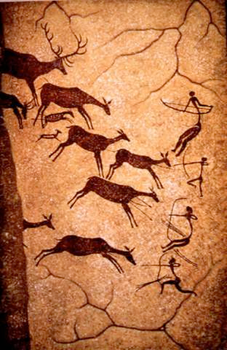
Figure 1: Cave painting found in Lascaux, France. Paintings are believed to have been made 16,000 years ago.
1. What animals are shown in the cave painting? Why do you think these animals are painted?

2. What tools are the people using in the picture?

3. What does the presence of art tell us about culture?

DOCUMENT #2
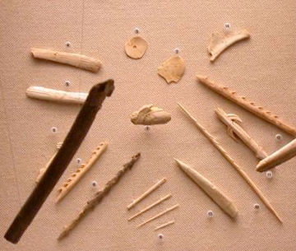
Figure 2: In addition to stone, early man used other materials for making tools. These materials included bones, antlers, teeth, and ivory. With these new materials, they were able to create sharper blades, needles for sewing, and fishhooks for fishing. Early man also invented new kinds of long distance weapons, such as bow and arrows and spear throwers

4. What were three types of materials that early man used to make tools? Why did early man make tools from these materials?

5. What were three types of tools that early man made? For what were these tools used?

DOCUMENT #3
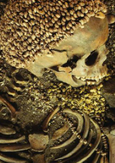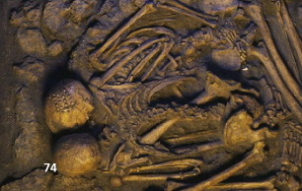
Figure 3 (on left): Scientists believe that the skeleton above was a boy around 18 years old. He was buried wearing a cap and necklace made of shells.

Figure 4 (on right): The two skeletons here were found in a Paleolithic (stone age) burial site in Italy.

6. What do these images suggest to you about the culture of these people?

DOCUMENT #4
“…The Ice Ages required a change in the way man could live. They forced him to depend less on plants and more on animals. The dangers of hunting on the edge of the ice also changed the ways early man hunted. It no longer made sense to stalk single animals, even if they were quite large. The better alternative was to follow herds — to learn and adopt their habits, including their wandering migrations. This meant places they settled were set by the food animal.”
Source: Jacob Bronowski, The Ascent of Man, Little, Brown and Company

7. Based on this document, what is one trait of early man? Explain how you know this.

DOCUMENT #5
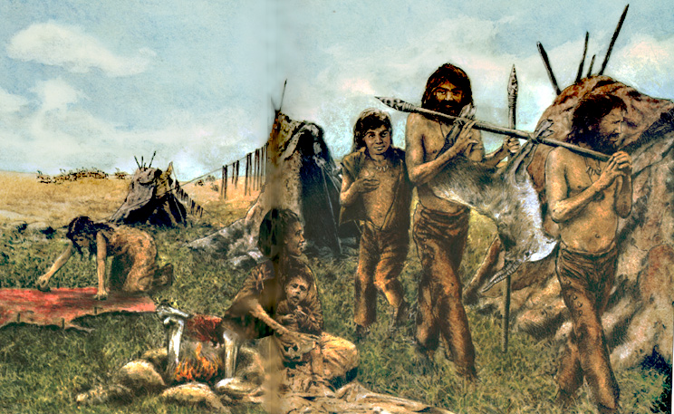

8. Using the image explain at least two ways that early man used animals?

9. Using the image explain the jobs of the women.

What was life like for prehistoric man?
Use at least 2 pieces of evidence to support your argument.

Consider the question above and develop a clear answer and introduction.

Using examples from prior knowledge and from the documents above create an outline:
- Body Paragraph 1
Topic Sentence:
Reason:
Evidence:

- Body Paragraph 2
Topic Sentence:
Reason:
Evidence:

- Conclusion
Concluding statement:

Part B: Now that you have organized your thoughts and arguments turn it into a short essay (2-3 paragraphs) including more detail and information to answer the question: What was life like for prehistoric man?

