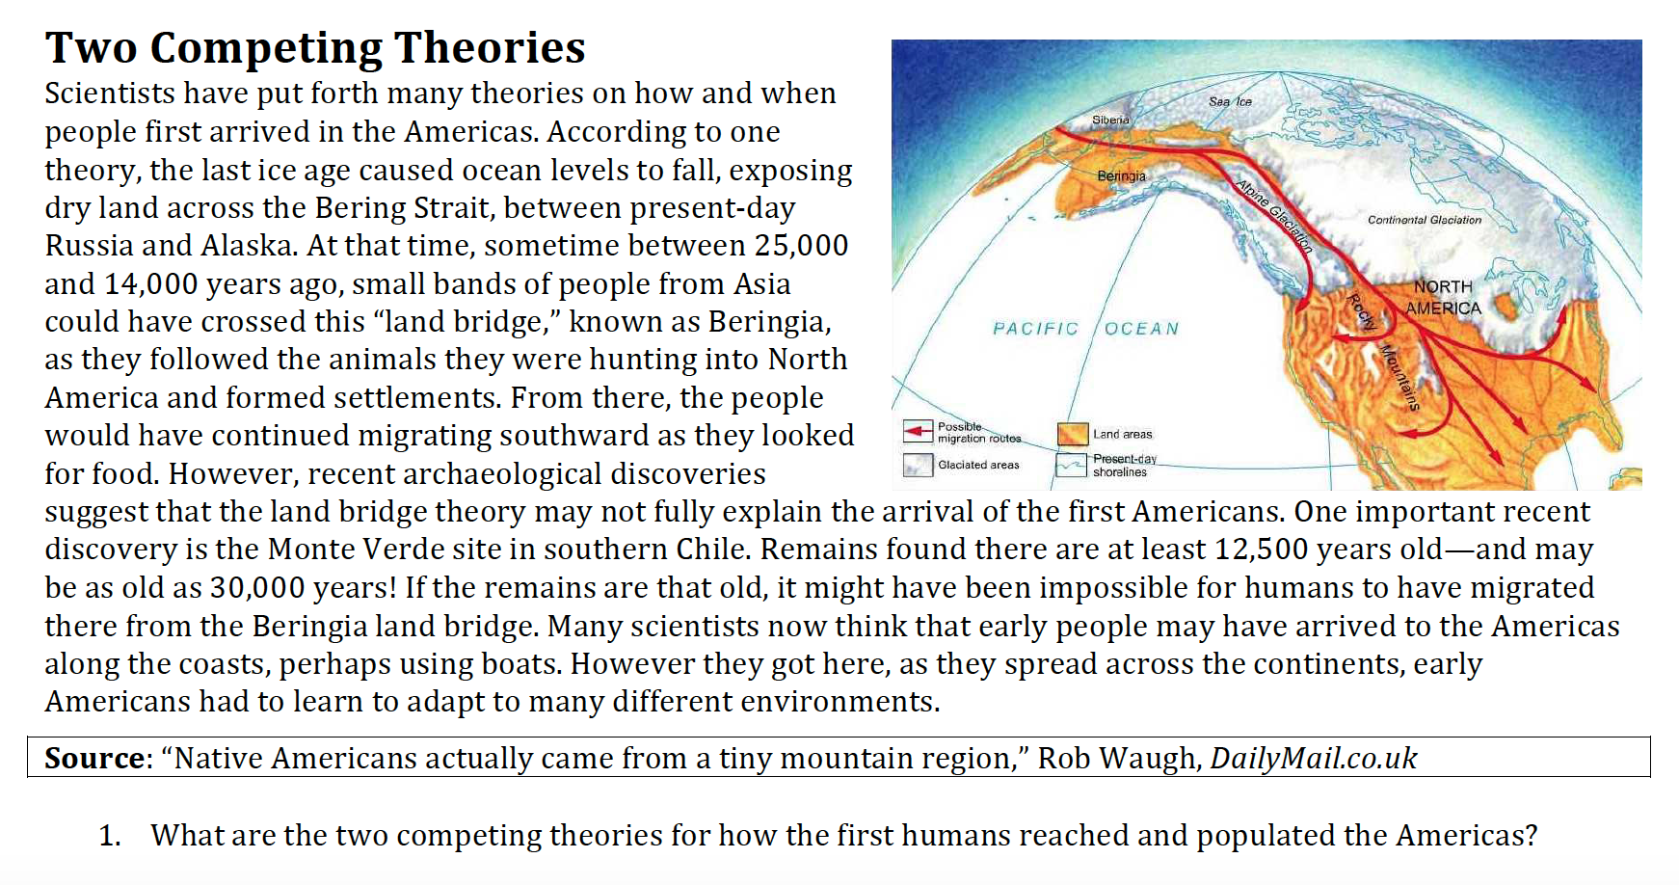

- What are the two competing theories for how the first humans reached and populated the Americas? Explain.

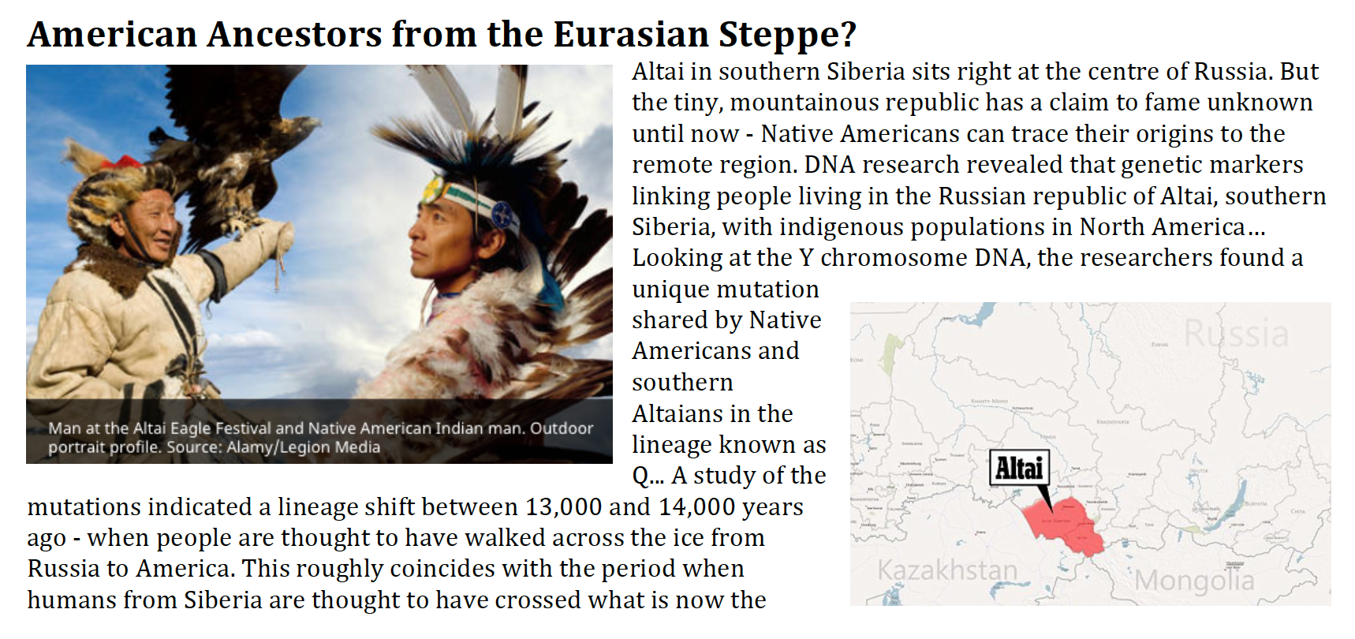
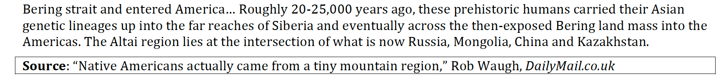

- What has genetic research revealed about the origins of Native Americans? How do they know this?

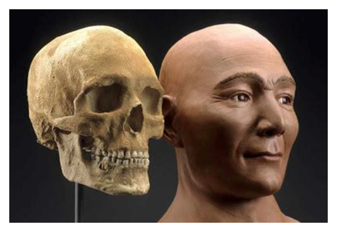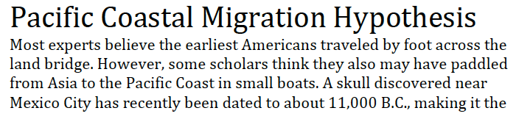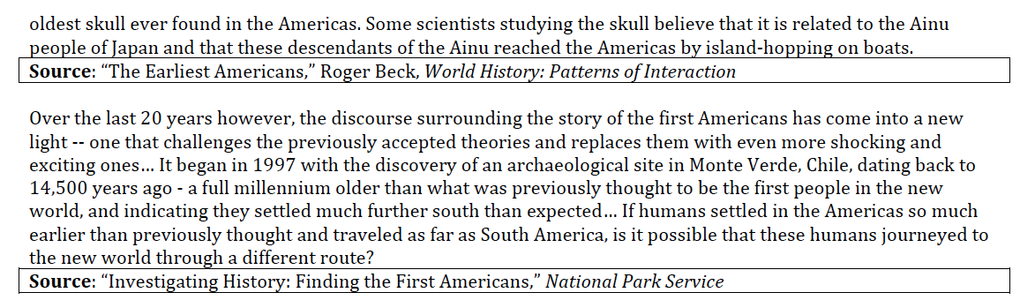
- How have archeological discoveries cast doubt on the Ice Free Corridor Hypothesis?

- Describe the discoveries and the reasons why they do not line up with the hypothesis.

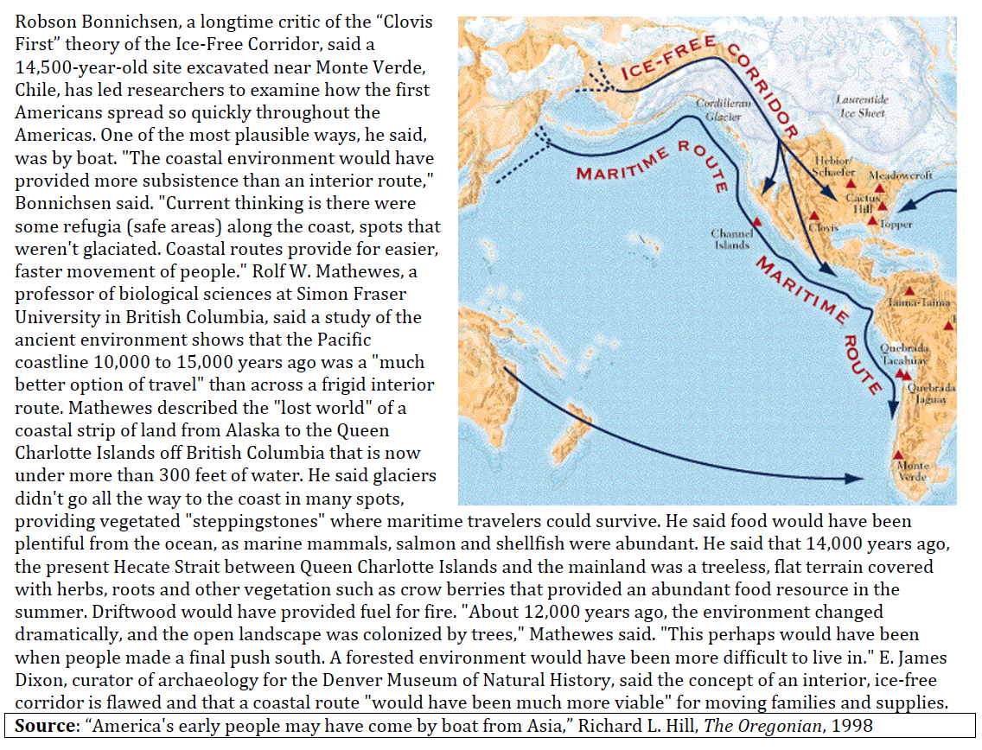
- How and why do experts believe humans may have first come to the Americas by boat?

- What resources would have been available to people along the coasts?
