Columbus: Discovery, Ecology and Conquest
In 1492, Christopher Columbus and his crew washed ashore in the Bahamas, "discovering" the New World and claiming ownership of it for the Spanish monarchy. The Taino Indians Columbus encountered—whose homeland he claimed for Spain—must have thought he was mad, suffering delusions of grandeur.
But, as we know, Columbus's arrival was indeed the first act in a centuries-long drama of colonization and conquest in which Europeans and their descendants largely displaced the Taino and their fellow Native Americans while remaking the Western Hemisphere in their own image.
How and why were the European colonists able to achieve such total dominance in far-off continents? Did the Europeans' power lie in their technological superiority, especially in weapons of war? Or was the European advantage ideological, rooted in the aggressive expansionism of crusading Christianity or the profit motive of entrepreneurial conquistadors? Was it simply a matter of the Europeans proving more brutally committed to a genocidal fight to the finish?
While a case can be made for the significance of any of these factors—or all of them—in truth the single most important factor in facilitating the European conquest of the Americas may be found, surprisingly, in a realm beyond simple human control: ecology.
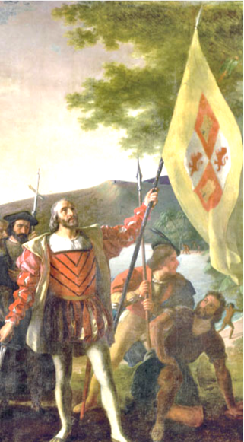

Unequal Exchange: Food for Disease
Columbus's ships, and those of the innumerable Europeans who followed him to America, short-circuited millions of years of divergent evolution in the two hemispheres by rapidly introducing Old World plants, animals, and micro- organisms into New World environments, and vice versa. This manmade reunion of the ecologies of the hemispheres—dubbed "The Columbian Exchange" by historian Alfred Crosby—had dramatically asymmetric consequences for the peoples of the Old World and the New.
The New World happened to be much a healthier place than the Old before 1492, hosting few or none of the devastating diseases that continuously plagued the populations of Europe, Africa, and Asia. Thus, when Europeans arrived, they generally found life in the Americas to be at least as healthy as back home. By contrast, American Indians—never before exposed to vicious Old World pathogens like smallpox and thus lacking any immunities to them—began dying at apocalyptic rates. Many historians now believe that new diseases introduced after Columbus's arrival killed off as much as 90% or more of the indigenous population of the Americas.
The Indians' "Great Dying"—which may have killed as many as one out of every five humans alive worldwide in the sixteenth century—ravaged not only Indian bodies but entire Indian societies and cultures. The traumatized survivors were often left unable to mount any effective resistance against the incursions of the European colonists.
The Columbian Exchange became even more unbalanced with Europe's successful appropriation of New World staple crops originally developed by Indians. The adoption of efficient, carbohydrate-rich American crops such as corn, potatoes, and cassava allowed Europeans and Africans to overcome chronic food shortages. Thus, even while Native American populations were decimated by Old World diseases, European and African populations swelled as American crops helped to overcome Old World famine.

History as Demography
Simple demographic numbers tell the story of the Columbian Exchange most starkly. When Columbus sailed the ocean blue, Europe's population stood at about 60 million. Most historians now believe that the population of the Americas at the same time stood somewhere between 40 and 100 million. In other words, it is not just possible but quite likely that American Indians outnumbered Europeans outright. (At its peak just before the Spanish arrival, the Aztec capital city of Tenochtitlan was more populous, cleaner, and more beautiful than Paris.)
But by 1800, after three centuries of the Columbian Exchange, Europe's population had surged to 150 million, while that of the Americas' fell to 25 million—of which the vast majority were descendants of European colonists or African slaves, not American Indians.
The success of European imperialism in the Americas was underwritten by the ecological imperialism of the Columbian Exchange. The European colonists who would eventually found the settlements that would become the United States had a powerful—if accidental—ally in the environment itself.

New World, New Foods
The Columbian Exchange of foods richly improved the European (and African) diet, not only by improving and diversifying its taste but also, in a more basic sense, by simply increasing Old World societies' abilities to feed more people. Starvation, which had long limited population growth in Europe and Africa, was largely overcome through the transplantation of New World foods.
Three staple crops of the Western Hemisphere—corn, potatoes, and cassava—proved to be much more efficient sources of carbohydrates than wheat, the old European standard. An acre of land planted in corn, potatoes, or cassava yielded twice as many calories as an acre planted in wheat. The increased caloric output of farmers who adopted New World crops helped to fuel a surge in Old World populations. In Ireland, for example, widespread peasant farming of the potato allowed the population to soar from barely one million in 1670 to more than 8 million by the time of the infamous Potato Blight of the 1840s. Cassava, a tropical root plant, thrived in the impoverished soils of equatorial Africa, helping to support a population boom in the Congo. (Much of that new population would end up transplanted, involuntarily, to the New World through the Atlantic slave trade.)
In the cases of both Irish potatoes and African cassava, New World plants transplanted to Old World societies helped to sustain millions of lives—lives that were later used as reinforcements in the European colonization of the Americas. Whether or not of their own free choice—largely not, in the case of both Irish and Africans—millions of people nourished on American foods would eventually follow in Columbus's footsteps to repopulate a New World whose native inhabitants had been decimated by disease.
At the same time, the colonies the Europeans established in the New World soon became efficient producers of not only New World crops, but Old World transplants as well. Thus did North America become a key producer of not only corn but also wheat, while the Caribbean and South America came to host the world's greatest plantations of Old World cash crops such as sugar and coffee.
The Columbian Exchange of foodstuffs vastly increased the health and wealth of Europeans and their colonists in the Americas.

Continental Drift
Tectonic forces broke up the ancient supercontinent of Pangaea about 180 million years ago, sending the Americas slowly drifting away from the continents of the Old World (Eurasia and Africa). From that time until 1492, the plants and animals living in the two hemispheres experienced continuous, divergent evolution. Periodic openings of the Bering Land Bridge during Ice Ages did allow animals (humans prominent among them) to migrate from Asia to America, but despite these occasional contacts the human-shaped ecosystems of the two hemispheres developed very different characteristics.
Crossing the "Seams of Pangaea"
Columbus's ships, ferrying people, plants, animals, and diseases between the Old World and the New, instantly reconnected ecosystems that had developed in complete isolation from one another for millennia. According to historian Alfred Crosby, who developed the concept of the Columbian Exchange, the voyages of Columbus and his successors re-knitted the torn "seams of Pangaea," which had ripped apart by continental drift millions of years before. Suddenly, the separate ecologies of the Eastern and Western Hemispheres merged into a single, worldwide, man-made ecosystem. The ecological effects were dramatic, and—in ways entirely unforeseen and misunderstood by both Europeans and Indians at the time—they systematically favored the peoples of the Old World in their encounters with Native Americans.
The profoundly uneven nature of the Columbian Exchange colored all subsequent American history.

New World and Old World
The people of the New World cultivated a number of highly nutritious plant species, South American potatoes and Central American maize (a.k.a. corn) foremost among them. Thousands of years ago, the people of southern Mexico successfully bioengineered maize from strains of inedible teosinte grass. The Indian creation of corn, one of the world's most calorie-efficient grains, was one of the most significant technological accomplishments of ancient man; widespread cultivation of the highly nutritious corn eventually allowed the agriculturalists of the central Mexican plateau to support the huge, stationary populations needed to sustain a great civilization.
The New World's wealth in produce was offset by a poverty in domesticable animals. Indians throughout the Americas kept dogs, and the natives of the Andes tamed the llama, but no other animal species of the Americas proved amenable to domestication. Indian hunger for meat had to be met by hunting wild game.
In the Old World, the situation was quite different. Plant sources of carbohydrates were less robust, but Europeans, Africans, and Asians learned to domesticate a multitude of useful animals—horses, pigs, cows, oxen, chickens, sheep, goats, and camels, among others—which provided them with meat, milk, clothing and transportation.
The drawback of Old World civilizations' reliance upon domesticated animals came in increased incidence of disease. Many of the world's nastiest illnesses derive from bugs that have leapt back and forth between people and their animals. Humans caught smallpox from their cows, influenza from their fowl, bubonic plague from the rats who lived in their houses. By the time of Columbus, the Old World was wracked by endemic contagions of dozens of deadly diseases, which kept life expectancies low and infant mortality rates high. Largely due to the ravages of disease (especially bubonic plague), the population of Europe in 1492 was lower than it had been 200 years earlier.
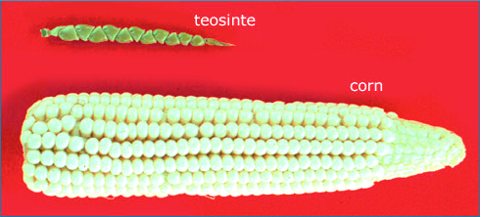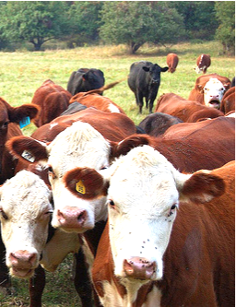

Disease: The Greatest Conquistador
Jared Diamond, best-selling author of Guns, Germs, and Steel, popularized the notion that European imperialism succeeded due to European advantages over other people in the areas of, well... guns, germs, and steel. As far as colonization of the Americas is concerned, though, guns and steel were all but immaterial. The germs alone were enough.
The word "conquistador" evokes memories of Cortés and Pizarro, but in truth the greatest conquistadors of the New World were smallpox and influenza—not to mention typhoid, cholera, tuberculosis, measles, scarlet fever, yellow fever, and malaria.
Every one of these diseases, endemic to the Old World, spread to the Americas after 1492 with catastrophic effects for indigenous people there. (In return, the Americas afflicted the Old World with only one major affliction— syphilis. And even that is in dispute; scientists and historians remain divided on whether the disease truly originated in the New World.)
Old World diseases—lethal enough already on their continents of origin— became exponentially more dangerous in America, where they spread as virgin-soil epidemics among native populations totally lacking in immunities to them. (In Europe and Africa, countless children died from diseases like smallpox and malaria; those who survived, however, built up antibodies that inoculated them against adult infection. Since no Native Americans had ever encountered these diseases, none built up any immunity, leaving entire populations as "virgin soil" for infection. When the diseases struck, entire communities could be felled in a matter of days.)
Virgin-soil epidemics are among the deadliest phenomena ever experienced by humankind, and the death toll of the pandemics unleashed in the Americas by the Columbian Exchange far exceeded that of history's most famous virgin-soil epidemic, Europe's Black Death (an outbreak of bubonic plague in the 1340s). The cataclysmic effects of virgin-soil epidemics struck Native American societies just as they faced the threat of European invasion, decisively reducing the natives' capability to resist colonization. (It is worth noting that devastating smallpox pandemics struck both the Aztecs and Incas just before their respective disastrous encounters with Cortés and Pizarro.)
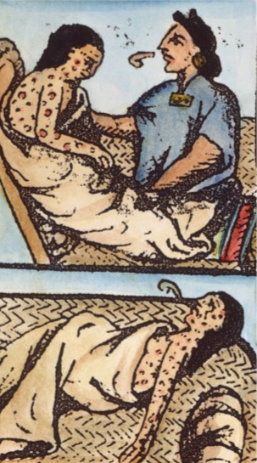
Mississippian Mystery: De Soto and La Salle
Perhaps the most arresting evidence of the consequences of virgin-soil epidemics came from the entrada of Hernando de Soto, who led an army of conquistadors deep into the North American mainland in 1539. De Soto hoped to find gold in the country that today comprises the southeastern United States; he ended up leading more than 600 men and hundreds of livestock on a four-year wild goose chase. In the end, his mission proved to be a fiasco—two-thirds of the men, including De Soto himself, died without ever finding a trace of gold—but De Soto's expedition powerfully illustrated the destructive force of smallpox, which apparently spread from his pigs to the people of the Mississippi Valley. Before leaving, De Soto's men recorded their impressions of the Mississippian people—they found dense settlements, with large villages and cities often sited within view of each other, separated by carefully tended fields of corn. After De Soto left the country, no European returned for more than 100 years. When the French explorer La Salle canoed down the Mississippi Valley in 1682, he found very few villages, no cities, and no fields of corn, but instead a landscape almost devoid of people and overrun by buffalo (which De Soto had apparently never encountered).
In the 140 years that passed between the explorations of De Soto and La Salle, something transformed the Mississippi Valley from a densely populated Indian heartland into a virtually deserted wilderness. That something was almost certainly smallpox. The landscape encountered by La Salle was not, as he believed, a primeval wilderness, but rather an ecosystem that had recently experienced the sudden destruction of its keystone species— Indians. The buffalo wandered in because few Indians survived to hunt them.
From Canada to the Tierra del Fuego, the indigenous inhabitants of the Americas suffered similar calamities, the Columbian Exchange of diseases ravaging Indian communities and facilitating the European takeover of the hemisphere.

American Transplants and European Traditions

What we now consider to be the "traditional" cuisines of Europe are heavily flavored with the products of the Columbian Exchange. Before 1492, the Italians—hard as it is to believe—ate no tomatoes. The Irish ate no potatoes, the Spanish no peppers, the Swiss no chocolate. For tomatoes, potatoes, peppers, and cocoa—like corn, cassava, peanuts, avocados, strawberries, pineapple, vanilla, and tobacco—are species native to the Western Hemisphere, brought back to Europe for the first time as the literal fruits of colonial success.
The rapid integration of American foodstuffs into European recipes was only the most obvious of the cultural adaptations brought on by the Columbian Exchange. On both sides of the Atlantic, people proved remarkably willing to reorganize entire social structures to make better use of previously unknown plants and animals.
Potatoes did not exist in Europe before 1492. They first appeared in Ireland sometime in the late sixteenth century, and very quickly the starchy tubers— high in calories, easy to cultivate, capable of rot-free storage in the ground—became the island's staple crop. The increased nutrition provided by potatoes allowed Ireland's population to explode, from 1 million in the middle of the seventeenth century to 8 million 200 years later. When a devastating potato blight struck the crop in the 1840s, the result was mass starvation and an exodus of millions of desperate emigrants. The terrible consequences of the Great Famine revealed, in tragic clarity, the incredible extent to which the potato—a favorite food of the Incas—had become an indispensable part of Irish culture and society.

European Horses and Comanche Culture
American Indians integrated European species into their socio-cultural traditions just as easily as vice versa. Horses were as alien to America in 1492 as potatoes were to Ireland. It did not take long, following horses' introduction to the New World by Spanish conquistadors, for Indians to appreciate the strange beasts' value in transportation, hunting, and warfare. The horse transformed Indian societies, and even created new Indian nations: The Comanche emerged as a distinct tribe around 1700, breaking away from the Shoshone in order to adopt a new nomadic lifestyle made possible only by the horse. The Comanche, who quickly developed an unrivalled reputation for skilled horsemanship, soon came to dominate the southern Great Plains. The horse—Europe's favorite domesticated animal—had become an indispensable part of Comanche culture and society.
Today, nothing could seem more "traditional" than the Irish potato or the Comanche on horseback. Yet those traditions are comparatively new, only made possible by the unprecedented ecological upheaval of the Columbian Exchange.
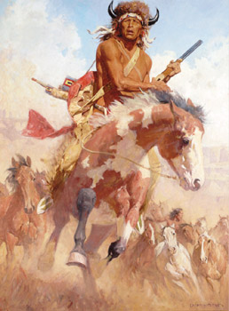

Ecological Imperialism Precedes English Colonization
The English colonists who founded the colonies that would eventually become the United States joined the quest for New World empires very late in the game. The first English attempts to colonize North America came a full century after the Spanish inaugurated the Columbian Exchange. The colonists of Jamestown and Plymouth Plantation thus arrived in landscapes—and among peoples—already heavily touched by the forces of ecological imperialism.
But they didn't know it.
When they arrived in America, English colonists found a landscape of great woods, abundant game, and relatively few Indians. Their mistake was to assume that it had always been this way. The forests the colonists mistook for primeval wilderness had in fact been more like orchards, carefully and deliberately shaped by Indian fires to provide better sustenance for human populations. And the small nomadic tribes the colonists mistook for the timeless inhabitants of those lands were, in fact, only the shattered survivors of history's worst population catastrophe. European diseases, arriving in places like Massachusetts and the Chesapeake long before permanent European settlers did, opened up the country for successful colonization.

Epidemic Disease and Manifest Destiny
Neither Europeans nor Indians had any scientific understanding of the ecological processes that had so profoundly shaped their encounter. Both groups understood phenomena like agricultural abundance or epidemic disease in spiritual terms, as the respective blessings or punishments of their gods.
Thus, the undeniable facts of the European-American encounter—that Indians seemed to be wasting away, opening bounteous lands to the newcomers from across the Atlantic—acquired deep cultural and ideological meanings in the minds of the colonists who eventually founded the United States. Not understanding the scientific processes at work, Anglo-Americans interpreted their ongoing good fortune as proof of God's special endorsement of their nation.
For example, John Winthrop—Puritan elder and first governor of the Massachusetts Bay Colony—perceived divine blessing of the colonists' venture in the Indians' Great Dying: "For the natives," Winthrop wrote, "they are neere all dead of Small poxe, so as the Lord hathe cleared our title to what we possess."3 A Frenchman on La Salle's voyage down the Mississippi captured the idea even more bluntly: "Touching these savages, there is a thing I cannot omit to remark to you, it is that it appears visibly that God wishes that they yield their place to new peoples."4
Through generations of successful colonization—in which the descendents of Europe built some of the world's healthiest and wealthiest societies in the lands vacated by the Indians—white Americans' conviction that their presence in America had received a special blessing from God only grew stronger. The cultural and ideological origins of "manifest destiny" and "American exceptionalism" can be found in the exceptionally uneven terms of the Columbian Exchange. Only recently have we become fully aware that the special advantages enjoyed by Europeans in their encounter with Indians were bestowed less by God than by ecology.

