Station 1: The Estate System
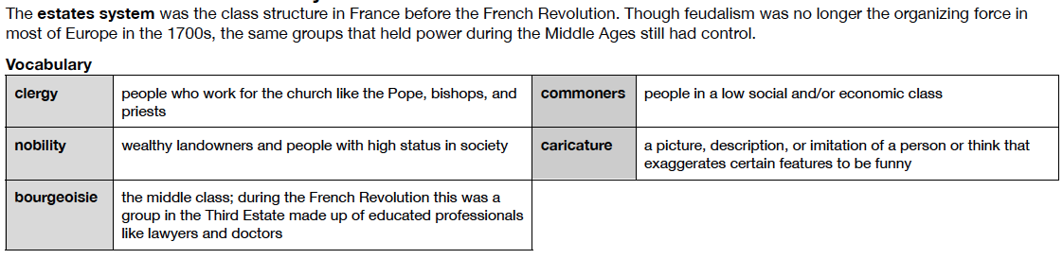

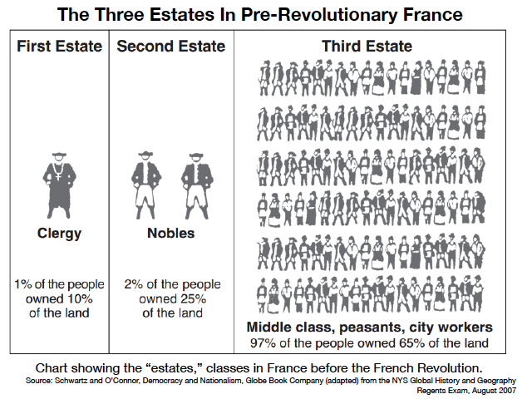
Station 2: The Three Estates in Pre-Revolutionary France
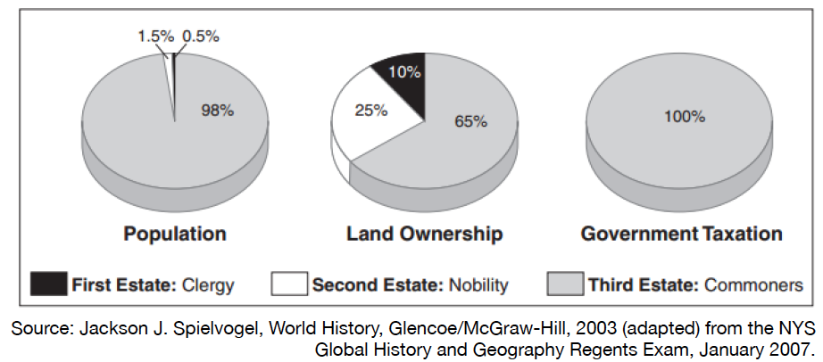

Station 3: The Three Estates painting
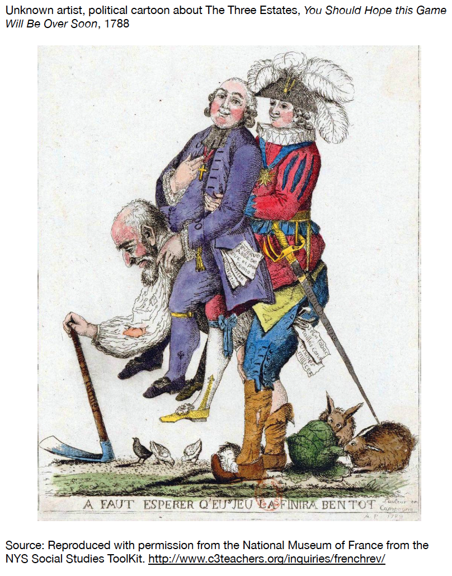
Station 4: Absolute Monarchy and Life at the Palace of Versailles

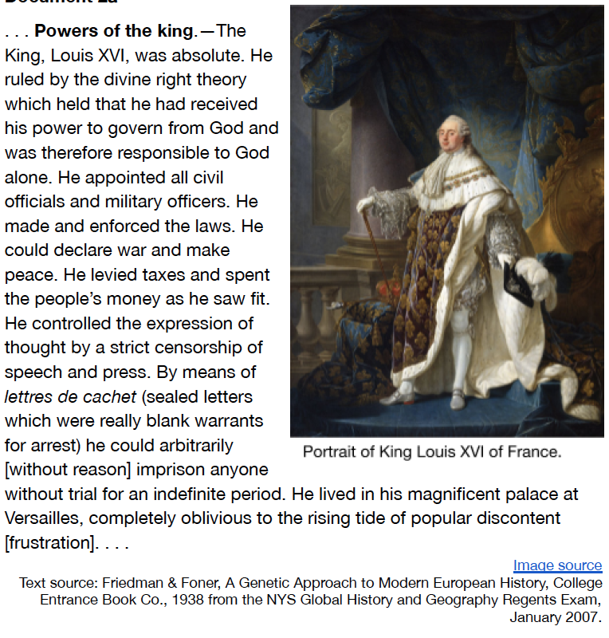
Station 5: Versailles
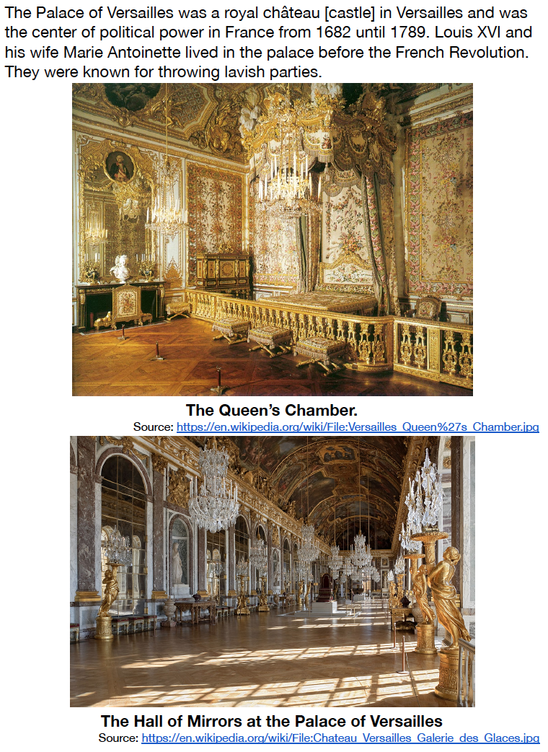
Station 6: The Lives of the Third Estate
Travels in France (1792) by Arthur Young
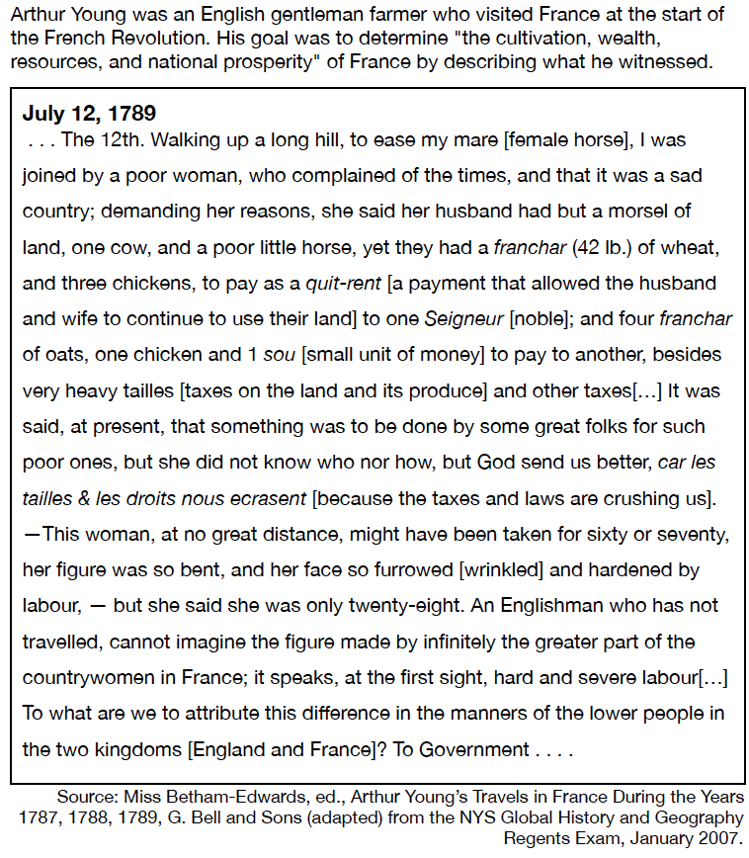
Station 7: Bad Harvests, National Debt, and the calling of The Estates General

Vocab: Grievance- a cause for complaint or protest especially for unfair treatment.
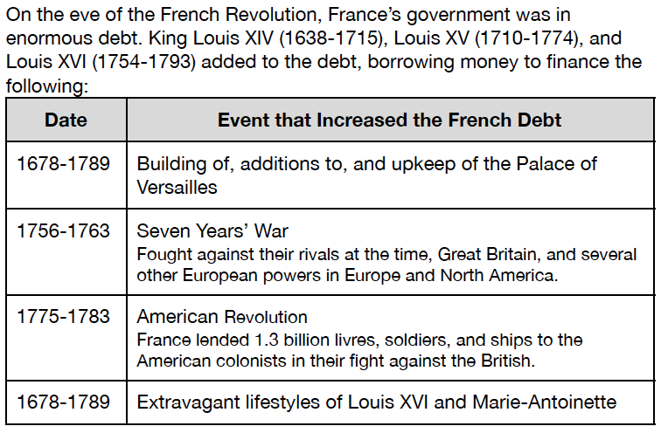

Station 8: Louis Calls the Estates General

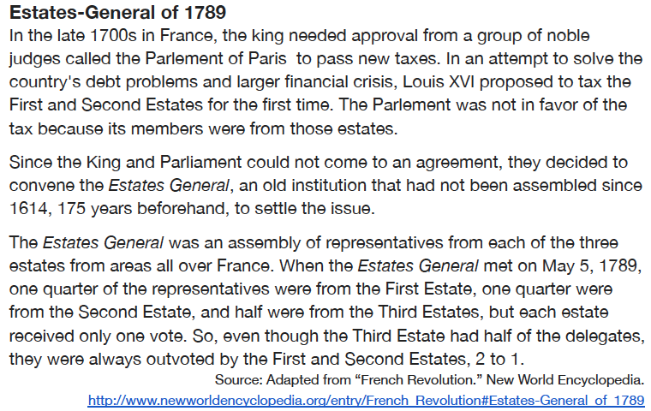
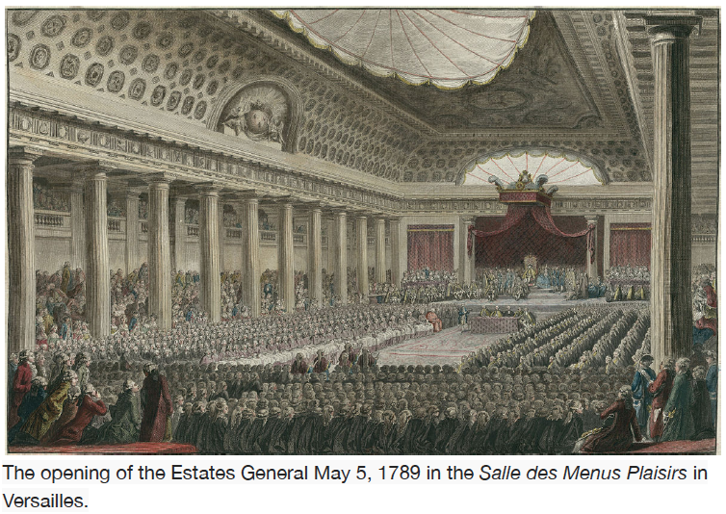
Station 9. Grievances
