Unit 5: French Revolution NAME:___________________

Part I.
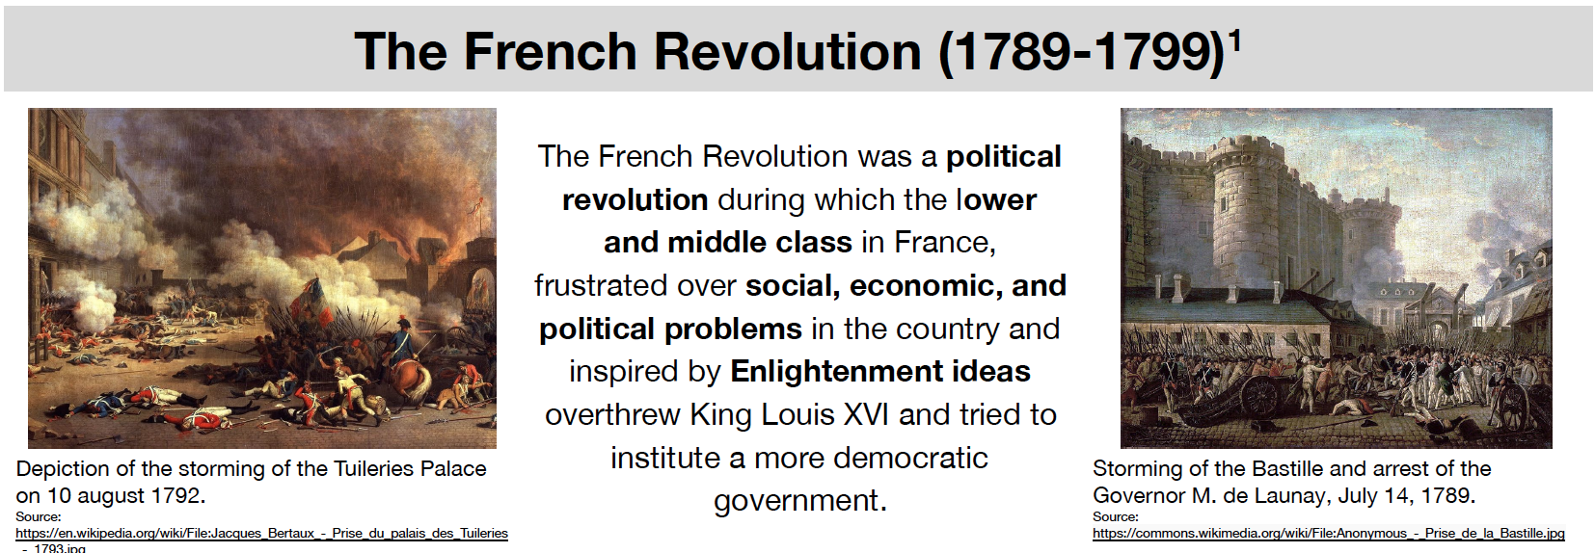
- Based on the video, identify two causes of the French Revolution.

- This was just an overview of the French Revolution. What would you like to learn more about?

Part II.
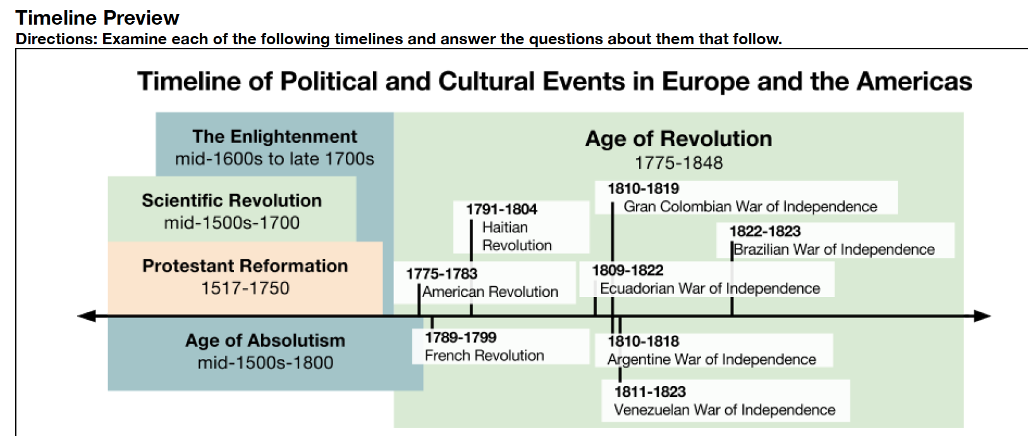
- According to the timeline above, identify five countries that had revolutions or wars of independence between 1775 and 1848.

- Which was the first country to rebel in the “Age of Revolution”?

- Based on the timeline, what earlier events may have cased the Age of Revolution? Why do you think that was?

Part III.
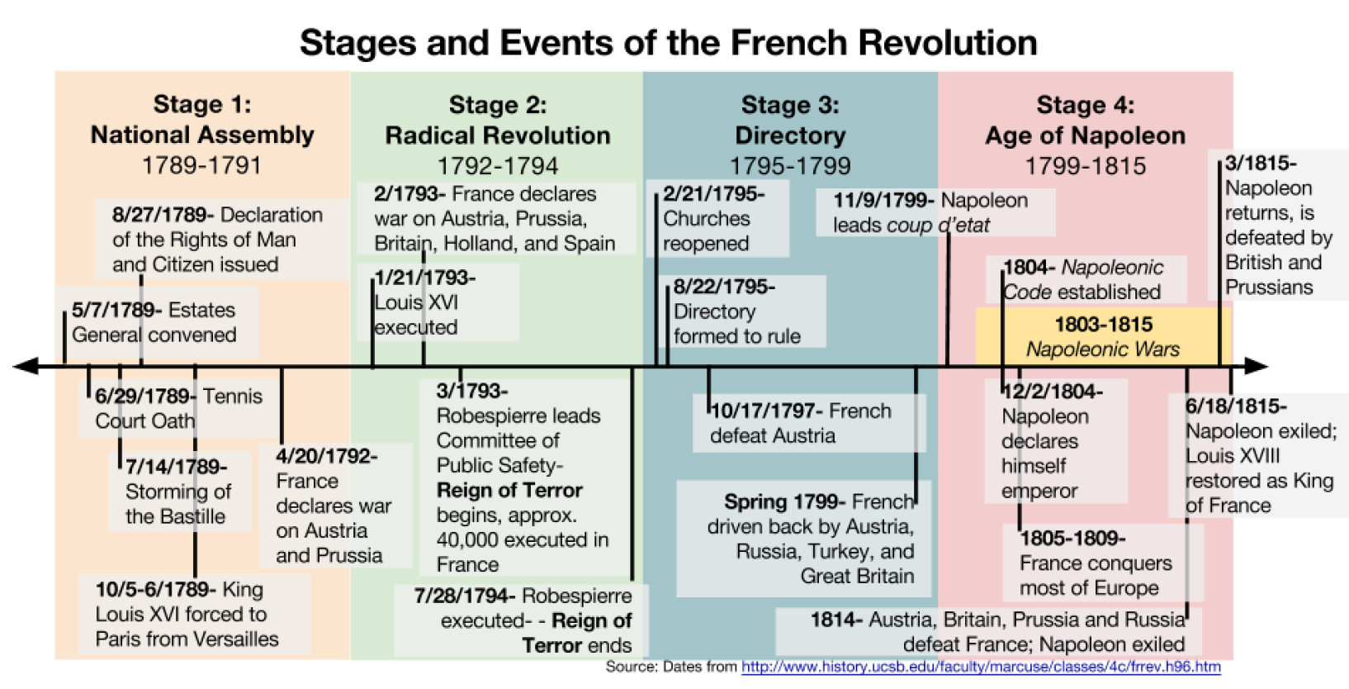
- Who ruled France at the start of the revolution? Who ruled France at the end?

- Why do you think the second stage of the revolution was called the “Radical Revolution”?

- What happened to King Louis XVI (16th) during the second stage of the revolution?

- Based on the timeline above, which countries opposed the revolution in France?

- Who do you think Napoleon was?

Part IV.
What were the social, economic, and political problems in pre-revolutionary France?
Directions: As you examine the documents about pre-revolutionary France, take down notes, write down direct quotes from the documents, or paraphrase what you read in the chart below. Group the information into “social”, “economic”, and “political” categories. (You can either do this as you go to each station or come back to it at the end)
Social | Economic | Political

Questions for each station:

Station 1.
- Based on the chart, identify which groups of people make up each estate.
  - First:

  - Second:

  - Third:

- What percentage of the population of France made up the Third Estate?

- When combined, what percentage of France’s population were the First and Second Estate? How much of the land in France did they own?

- If you were a member of the Third Estate, how would you feel about the “estates system”? Why?

Station 2.
- What does the amount of land that a group of people owns suggest about how wealthy they are?

- Based on the graphs identify the percentages of the taxes collected by the French government that each of the estates paid.
  - First:

  - Second:

  - Third:

- If you were a member of the Third Estate, how would you feel about taxation in the “estates system”? Why?

Station 3.
1.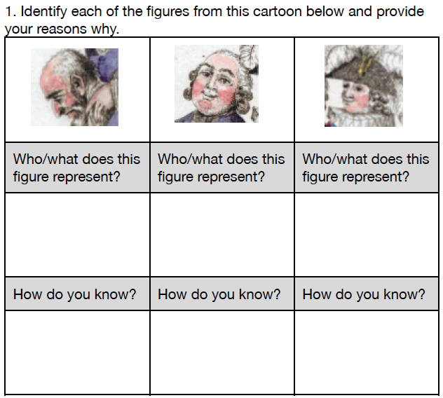

- How might someone from the First Estate, Second Estate, and Third Estate have reacted to this image in 1788? Would their reactions be different? If so, in what ways?

Station 4.
- What was the divine right theory?

- List five of Louis XVI’s powers as the King of France and place a checkmark in the appropriate column for the powers that Enlightenment Thinkers would not support and those that might worry members of the Third Estate.
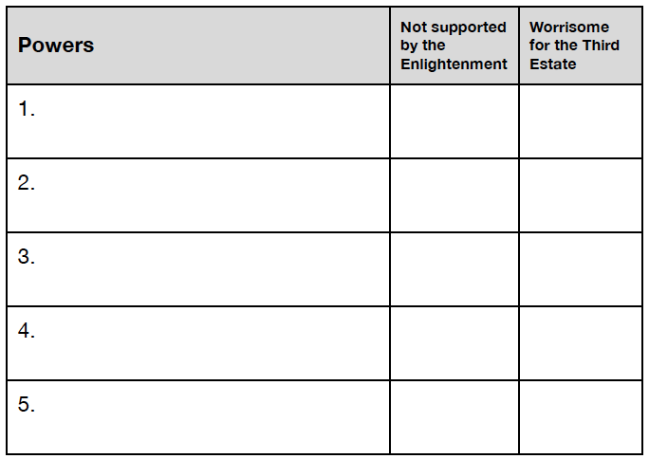

Station 5.
- Based on the images of the Palace of Versailles, describe the lives of the royal family (Louis XVI, Marie Antoinette, and their children)

Station 6.
- The “poor woman” that Arthur Young meets on the road says that France, or at least the region she lives in is “a sad country.” Identify two reasons why she says that.

- Compare the life of the woman Arthur Young met to the lives of Louis XVI, Marie Antoinette, and other members of the First and Second Estates.

Station 7.
- What did the kings of France send money on that put the country into debt?

- If you were a member of the Third Estate, how would you feel about the country’s debt problem? Who would you blame?

Station 8.
- What did King Louis XVI propose to solve the country’s debt problem?

- Why did the Parliament reject Louis’s idea?

- What was the Estates General? Who was part of it?

Station 9.
- Paraphrase each of the grievances listed below, then explain why members of the Third Estate would include that grievance in the cahiers.

