WWI/WWII

Leader phone activity.

After getting to know your fellow leaders you will work on the smart phone, your “phone” must relate specifically to YOUR leader and you must turn in your own individually! You must include the following sections…

* **Contacts**: At least 3 people your person might communicate or be friends/enemies with. Who do they share interests with? Include a picture for each contact (can be the face of the person or an object to represent them).
* **Twitter**: Write 5 tweets from your person (140 characters only! Be creative!)
* **Facebook**: Your person must “like” 5 things (pictures, “memes,” pages, etc.)
* **Music**: Make a playlist with at least 5 songs that relate to your person. The songs do NOT need to be from the time period. ***Explain WHY you picked each song below.***
* **Text**: Make a text conversation between your person and someone else from the time period (find a fellow leader to team up with)

Music explanation:

1.

2.

3.

4.

5.

Leader’s Cell Phone  
Your Name: ____________________________ Class Period: _________



Contacts

Text Messages

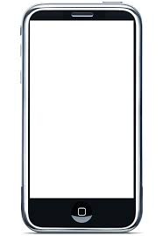

Twitter

**Phone’s Owner:  
_____________________**

(Lock Screen Photo)

Facebook

Music