1 | What was war like in WWI? How did it affect those involved?  Objectives: Describe the characteristics of WWI warfare and explain the effects of these characteristics on those involved.

Introduction
Directions: Examine the images below and answer the questions that follow.
Detailed section of a painting of Battle of Moscow, 7th September 1812, during the Napoleonic Wars.  Source: https://commons.wikimedia.org/wiki/File:Battle_of_Borodino_1812.png (click for a more detailed image) | 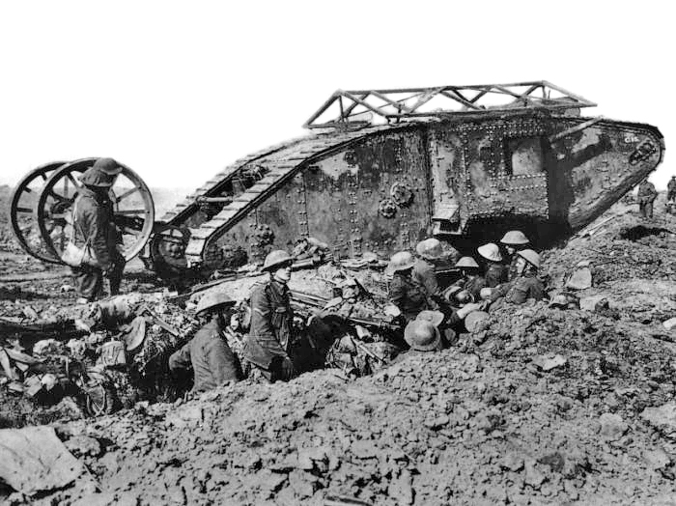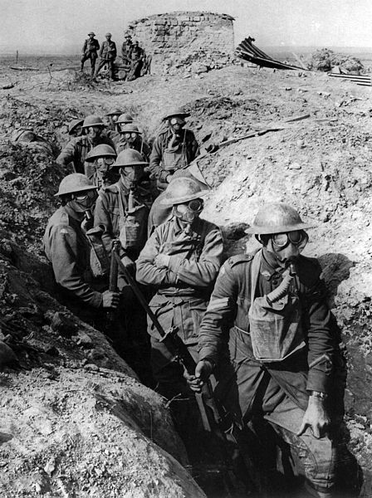  Images of warfare during WWI (1914-1918).  Sources: https://commons.wikimedia.org/wiki/File:Vickers_IWW.jpg; https://commons.wikimedia.org/wiki/File:Australian_infantry_small_box_respirators_Ypres_1917.jpg; https://en.wikipedia.org/wiki/File:British_Mark_I_male_tank_Somme_25_September_1916.jpg; https://en.wikipedia.org/wiki/File:The_Battle_of_the_Somme,_July-november_1916_Q1308.jpg

WWI Warfare Document Exploration
Directions: As you examine the text, images, and video provided about the characteristics of WWI warfare, complete the graphic organizer below.
Characteristics of WWI Warfare and Their Impact on Those Involved
Industrialization

1. How did industrialization in Europe affect the production of goods needed for WWI?

2. How did this industrialization affect soldiers and those on the homefront in WWI?

Total War

3. What is total war? How is total war different than most wars fought before WWI?

4. How did total war affect soldiers and those on the homefront in WWI?

Technological
Developments

5. Describe three technological developments in warfare during WWI.

6. How did technological developments during WWI affect the soldiers who fought?

Trench Warfare

7. Explain what trench warfare is.

8. How did trench warfare affect the soldiers who fought in WWI?

Industrialization
By the late 1800s, the process of industrialization had transformed most of Europe. Factories and densely populated urban areas dotted the landscape and railways connected them together. Advances in industrial production made manufacturing faster, and enabled factory owners to produce more complicated goods with precision. Factories used assembly lines to speed up production. With an increase in support and money from governments during the war, factories could mass produce guns, tanks, airplanes, automobiles, ammunition, and replacement parts needed for the war effort.

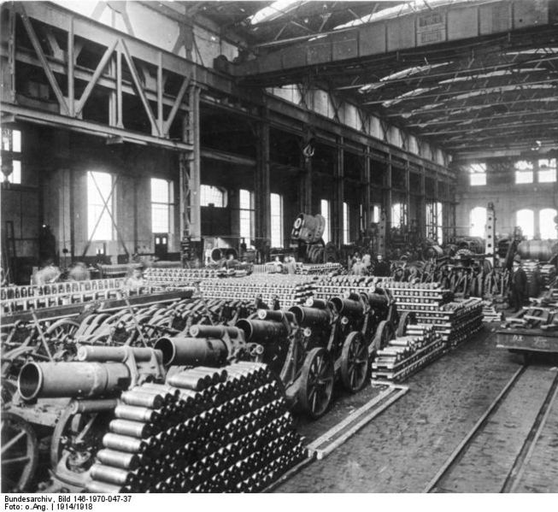  German munitions (weapons) factory, 1916.  Source: https://en.wikipedia.org/wiki/Economic_history_of_World_War_I#/media/File:Bundesarchiv_Bild_146-1970-047-37,_Munitionsfabrik.jpg | 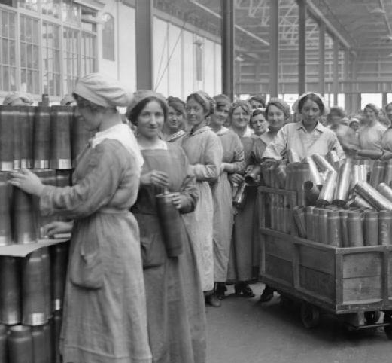  Women munition workers stacking cartridge cases in the New Case shop at the Royal Arsenal, Woolwich, 1918.  Source: https://en.wikipedia.org/wiki/File:Cartridge_cases_at_Woolwich_Arsenal_1918_IWM_Q_27848.jpg | 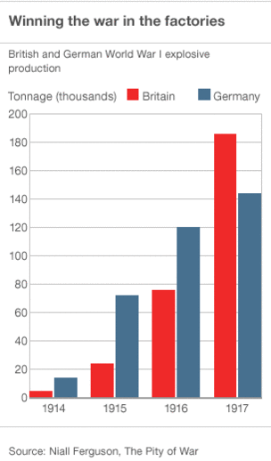  The chart above shows industrial output in Great Britain and Germany over the course of the war. Note how the British produced more goods as they started to have more success against the Germans.

Total War
A total war is a military conflict in which nations are willing to make any sacrifices necessary to win. In a state of total war, a nation will mobilize, or make us of its total available military, technology, and human resources to be victorious. In a state of total war, there are no limits to the weapons used, the territory or combatants involved, or the goals. Total war is considered the most extreme form of warfare because both civilians and soldiers are targets.
In addition to dedicating time and money to build new war technologies, European women at home were mobilized to work outside of the home to replace men who went off to war. Additionally, hose at home were asked to make the sacrifice of rationing. Rationing was a policy of strictly distributing food to ensure that soldiers had enough food. Sugar, meat, flour, butter, margarine and milk were tightly controlled and families were urged to consume less.
During the war, propaganda posters were used to influence people's decisions and to increase support towards the war effort.
Source: Adapted from https://www.britannica.com/topic/total-war, https://en.oxforddictionaries.com/definition/total_war, http://www.bbc.co.uk/schools/0/ww1/26439020, http://www.encyclopedia.com/history/educational-magazines/home-front
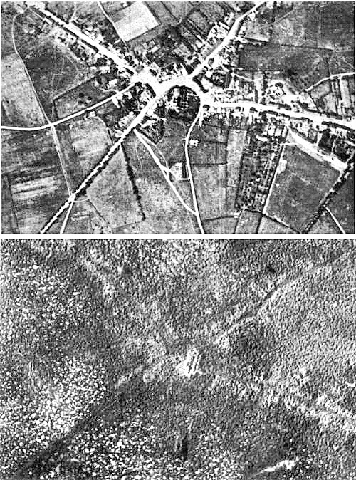  Aerial view of the village of Passchendaele, Belgium before and after WWI. In a total war, civilian and military buildings are targets.  Source: https://commons.wikimedia.org/wiki/File:Passchendaele_aerial_view.jpg | 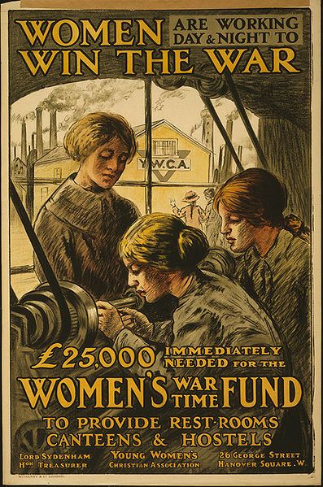  War poster : Women are Working Day and Night to Win the War / Witherby & Co. London, 1915.  Source: https://en.wikipedia.org/wiki/File:Affiche-guerre_Femmes-au-travail.jpg | During World War I, the British government relied heavily on loans to finance the cost of the war. This 1915 posters, encourages British citizens to give metal and money to the war effort.  Sources: http://www.wdl.org/en/item/581/
Technological Developments
Advances in industrial production and competition between countries led to technological and scientific achievements that were used in World War I. Below are some of those that made the greatest impact.
Watch History.com video on technological developments in WWI then analyze the images and text below.
Machine Guns | Chemical Warfare | Submarines
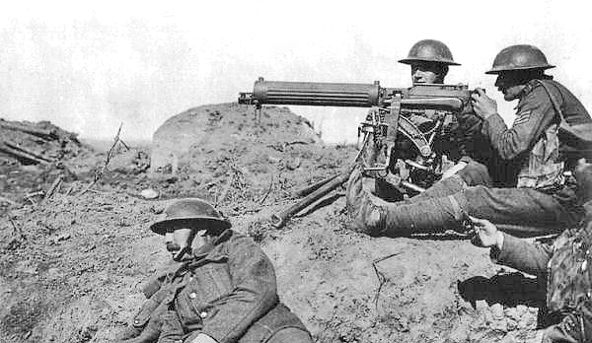  British Vickers machine gun crew during the Battle of Menin Road Ridge, World War I (Ypres Salient, West Flanders, Belgium).  Source: https://en.wikipedia.org/wiki/File:Vickers_IWW.jpg | 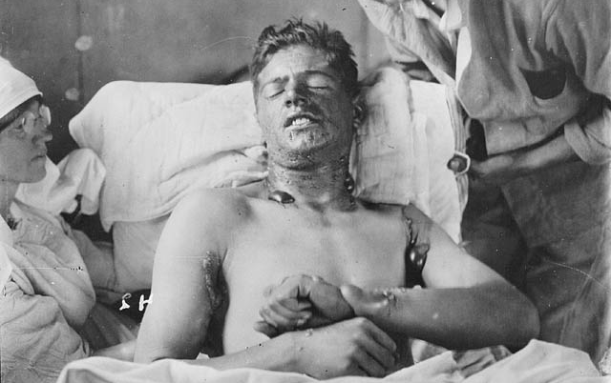  A Canadian soldier with mustard gas burns, ca. 1917-1918.  Source: https://commons.wikimedia.org/wiki/File:Mustard_gas_burns.jpg  The first use of chemical weapons of mass destruction were during World War I. The use of chemical weapons such as chlorine and mustard gas were not only a threat to soldiers but also civilians and those who worked to manufacture these weapons. The French were the first to use chemical weapons during the First World War, using tear gas. The German's first use of chemical weapons were shells containing xylyl bromide, an early form of tear gas, that were fired at the Russians near the town of Bolimów, Poland in January 1915.  Source: Adapted from https://www.ncbi.nlm.nih.gov/pmc/articles/PMC2376985/, http://www.bbc.com/news/magazine-31042472 | 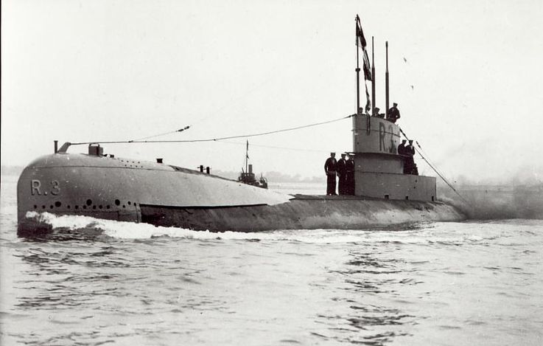  British R-class submarine.  Source: https://en.wikipedia.org/wiki/File:British_WWI_Submarine_HMS_R3.JPG
Airplanes |  | Tanks
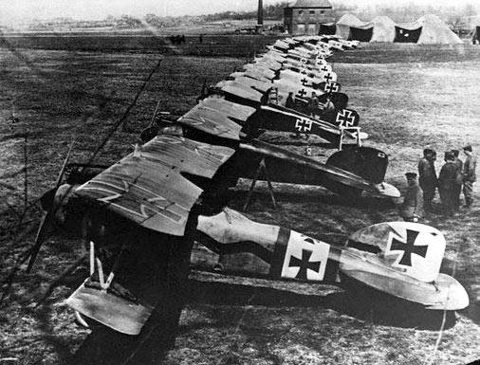  German Albatros D.IIIs of Jagdstaffel 11 and Jagdstaffel 4 planes parked in a line at La Brayelle near Douai, France. Source: https://commons.wikimedia.org/wiki/File:AlbatDIII.jpg |  | 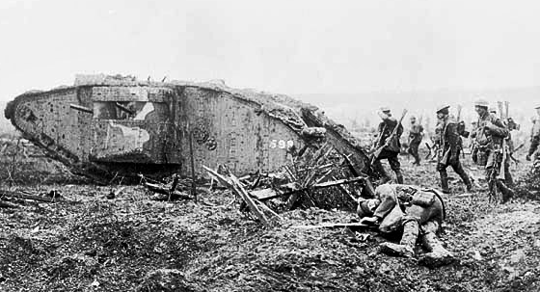  Mark II Tank Number 598 advancing with Infantry at Vimy. April 1917.  Source: https://en.wikipedia.org/wiki/File:Canadian_tank_and_soldiers_Vimy_1917.jpg

Trench Warfare
At the start of the war, both sides thought that WWI would be fought in the open like previous wars had been. Once they realized how accurate and effective the new artillery and machine guns were, they needed a new tactic. Both sides dug a series of trenches to protect themselves from enemy fire. Most of WWI, especially in the Western Front in France and Belgium, was fought through trench warfare. One side would attack by climbing out of their trench, over the dangerous section known as “no man’s land,” and into the opposing trench to fight the enemy. Later, the other side would do the same thing to win back that trench, gaining only a small amount of land and losing a lot of soldiers to machine gun fire, grenades, and gas. This resulted in a stalemate, a position in which neither side could win.
Watch History.com video on trench warfare in WWI, this scene from the film All Quiet on the Western Front and/or this excerpt from the History Channel show Conquest then analyze the images and text below.
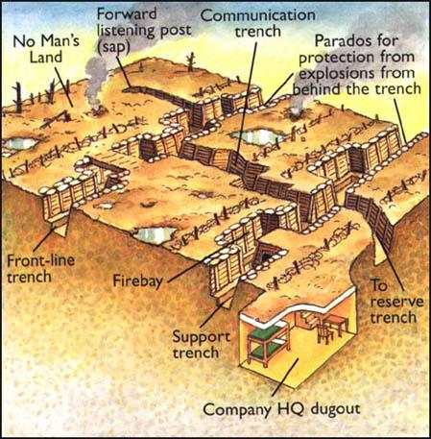  Illustration from Neil Demarco The Great War  Source: http://spartacus-educational.com/FWWsapping.htm | 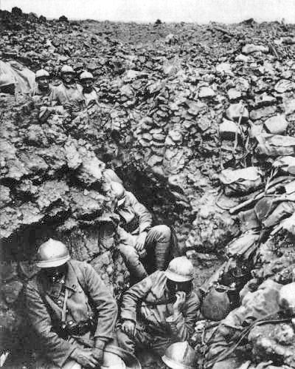  French soldiers in a trench northwest of Verdun, 1916. https://en.wikipedia.org/wiki/File:French_87th_Regiment_Cote_34_Verdun_1916.jpg

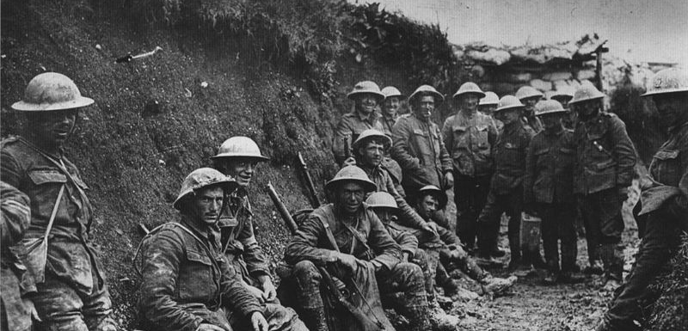  A ration party of the Royal Irish Rifles in a communication trench during the Battle of the Somme. The date is believed to be 1 July 1916, the first day on the Somme, and the unit is possibly the 1st Battalion, Royal Irish Rifles (25th Brigade, 8th Division).  Source: https://en.wikipedia.org/wiki/File:Royal_Irish_Rifles_ration_party_Somme_July_1916.jpg | 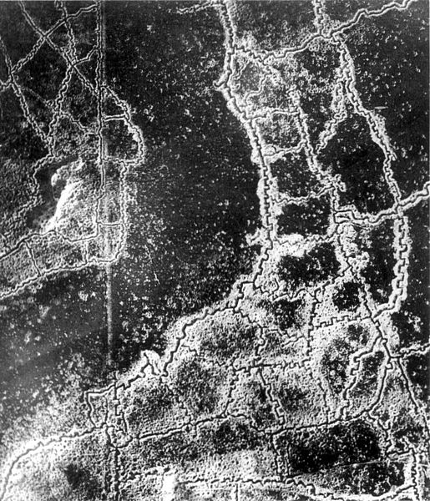  An aerial reconnaissance photograph of the opposing trenches and no-man's land between Loos and Hulluch in Artois, France, taken at 7.15 pm, 22 July 1917. German trenches are at the right and bottom, British trenches are at the top left. The vertical line to the left of center indicates the course of a pre-war road or track.  Source: https://commons.wikimedia.org/wiki/File:Aerial_view_Loos-Hulluch_trench_system_July_1917.jpg
Voices of Soldiers
“We have been in camp near the wood at Écurie for some days now and a more miserable existence it would be hard to imagine. There is nothing but unrest and uncertainty and everyone here is absolutely fed up to the teeth.”
- Private Archie Surfleet, February 8th, 1918

"Bombardment, barrage, curtain-fire, mines, gas, tanks, machine-guns, hand-grenades — words, words, but they hold the horror of the world.”
- Erich Maria Remarque, All Quiet on the Western Front
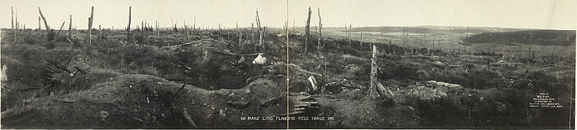
No Man’s Land, Flanders Field, France, 1919. Source: https://en.wikipedia.org/wiki/File:No-man%27s-land-flanders-field.jpg
Formative Assessment Task
Napoleonic Wars  Location: Europe  Dates: 1803-1815  Deaths: 3,500,000 - 6,000,000 | World War I  Location: Worldwide, but mostly in Europe  Dates: 1914-1918  Deaths: 20,000,000  Source: https://en.wikipedia.org/wiki/List_of_wars_by_death_toll
Detailed section of a painting of Battle of Moscow, 7th September 1812, during the Napoleonic Wars.  Source: https://commons.wikimedia.org/wiki/File:Battle_of_Borodino_1812.png (click for a more detailed image) | Images of warfare during WWI (1914-1918).  Sources: https://commons.wikimedia.org/wiki/File:Vickers_IWW.jpg; https://commons.wikimedia.org/wiki/File:Australian_infantry_small_box_respirators_Ypres_1917.jpg; https://en.wikipedia.org/wiki/File:British_Mark_I_male_tank_Somme_25_September_1916.jpg; https://en.wikipedia.org/wiki/File:The_Battle_of_the_Somme,_July-november_1916_Q1308.jpg

Directions: After examining all of the documents and the statistics above, complete the task below.
Task: | Using information from the documents and your knowledge of global history, write a two paragraph response in which you
- Identify two reasons why there were more deaths in WWI than in the Napoleonic Wars
- Explain why/how these three reasons resulted in more deaths in WWI than in the Napoleonic Wars

